**MULTIMEDIA UNIVERSITY OF KENYA**

**FACULTY OF COMPUTING AND INFORMATION TECHNOLOGY**

**DEPARTMENT OF INFORMATION TECHNOLOGY**

**TEACHERS RECORD MANAGEMENT SYSTEM: A CASE OF GOSETA HIGH SCHOOL**

**PETER TELLAH MARTIN**

**CIT-222-026/2021**

RESEARCH PROPOSAL SUBMITTED IN PARTIAL FULFILMENT OF THE REQUIREMENTS OF THE AWARD OF BACHELOR OF SCIENCE IN COMPUTER TECHNOLGY IN MULTIMEDIA UNIVERSITY OF KENYA

**JUNE, 2025**

# 

# **DECLARATION AND APPROVAL**

**STUDENT**

I, the undersigned, declare that this proposal is my original work and that it has not been presented in any other university or institution for academic credit.

Signature ……………. Date………...

Student Name: PETER TELLAH MARTIN

Reg_NO: CIT-222-026/2021

**UNIVERSITY SUPERVISOR’S APPROVAL**This research proposal has been submitted for examination with my approval as University supervisor.Signature ….………………………… Date …….………………………………Names: DR. NICODEMUS ISHMAEL

Faculty of: COMPUTING AND INFORMATION TECHNOLOGY

**HEAD OF DEPARTMENT’S APPROVAL**This research proposal has been submitted for examination with my approval as Head of DepartmentSignature ….………………………… Date …….………………………………Names: HENRY NDITHI

Department of: INFORMATION TECHNOLOGY

# **ACKNOWLEDGEMENT**

First and foremost, I give thanks to the Almighty God for granting me strength, good health, and perseverance throughout the course of this project.

I would like to express my sincere gratitude to my supervisor, Dr. Ishmael nickodemus, for their continuous support, insightful feedback, and professional guidance during the research and development of the Teachers Record Management System (TRMS). Your mentorship has been invaluable to this project’s success.

Special appreciation goes to the **faculty and staff of Computing and Information Technology at Multimedia University of Kenya**, whose knowledge, resources, and assistance helped shape the direction of this work.

My heartfelt thanks go to the **school administrators, IT personnel, and teachers** who willingly participated in the data collection process and shared their experiences and expectations. Your contributions were essential in making this system user-centered and relevant.

I also acknowledge my **friends and classmates**, who provided support, collaboration, and motivation during challenging times.

Lastly, I am deeply grateful to my **family**, especially my parents and siblings, for their emotional, financial, and moral support throughout this academic journey. This achievement would not have been possible without your love and encouragement.

# **DEDICATION**

This project is wholeheartedly dedicated to:

**My beloved parents**, whose unwavering support, encouragement, and sacrifices have been the foundation of my academic journey. Your belief in the power of education continues to inspire me every single day.

**My lecturers and mentors**, for their invaluable guidance, constructive feedback, and motivation throughout the research and development of this system.

And most importantly, to all **teachers and educational administrators**, whose commitment to nurturing minds deserves the most efficient tools to support their noble profession. May this system contribute, in some small way, to making your work easier and more effective.

# **ABSTRACT**

*Managing teacher records is a critical aspect of educational administration, yet many institutions continue to rely on outdated manual or semi-digital systems that are inefficient, error-prone, and lack real-time accessibility. This project proposes the design and implementation of a* ***Teachers Record Management System (TRMS),*** *a web-based application aimed at streamlining the management of teacher data, including biodata, appraisals, promotions, and leave records. The system employs a secure, centralized database to ensure data integrity and confidentiality, while providing a user-friendly interface for different roles such as administrators, teachers, and auditors. Developed using PHP, MySQL, HTML/CSS, and JavaScript, TRMS incorporates modern features such as role-based access control, automated notifications, dynamic reporting tools, and audit trails to support transparency and informed decision-making. A mixed-methods approach was employed for system development, including interviews, questionnaires, and direct observation to gather user requirements. System design tools such as Data Flow Diagrams (DFDs), UML diagrams, and mock-up screens were utilized to guide development. Rigorous testing comprising unit testing, integration testing, system testing, and user acceptance testing was conducted to verify functionality, performance, usability, and security. The results indicate significant improvements in data accuracy, retrieval speed, and administrative efficiency. This research concludes that implementing a tailored digital solution such as TRMS can greatly enhance record management in educational institutions. Future recommendations include integrating mobile accessibility and machine learning for predictive analytics in teacher performance and workload.*

### Table of contents

DECLARATION AND APPROVAL i

ACKNOWLEDGEMENT ii

DEDICATION iii

ABSTRACT iv

List of figures xi

List of tables xii

Defination of key terms xiii

Teachers’ Record Management System (TRMS) xiii

Database xiii

Authentication xiii

User Interface (UI) xiii

System Administrator xiii

Data Integrity xiii

Access Control xiv

Data Backup xiv

User Acceptance Testing (UAT) xiv

1.0 INTRODUCTION 1

1.1 Background of the Study 1

1.2 Problem Statement 1

1.3 Objectives of the Study 2

Specific Objectives 2

1.4 Justification of the Study 3

1.5 Scope of the Study 4

1.6 Aim of Research 5

CHAPTER TWO: LITERATURE REVIEW 6

2.1 Introduction 6

2.2 History of the Research Topic 6

2.3 Review of the Related Work 7

2.4 Review of Related Prototypes, Systems [from global to local] 7

2.4.1 Global Perspectives 7

2.4.2 Regional Perspectives 7

2.4.3 Local Perspectives 8

2.5 Emerging Trends and Patterns in the Research Area 8

2.6 Research Gap to be Filled by Your Research 9

2.7 Chapter Summary 9

CHAPTER THREE: METHODOLOGY 10

3.1 Introduction 10

3.2 Methodology for Literature Review 11

3.3 Methodology for Requirement Specification, Data Collection, and Analysis Techniques 11

3.3.1 Requirement Specification 11

3.3.2 Data Collection Techniques 11

3.3.3 Interviews 11

3.3.4 Use of Questionnaires 11

Section B: Current System Evaluation 12

Section C: TRMS Feature Priorities 12

Section D: Usability Preferences 13

Section E: Open-Ended Feedback 13

Implementation Questions 13

3.3.5 Observations 14

3.4 Methodology for System Analysis of the Current System 14

3.4.1 Data Flow Diagram (DFD) 14

3.4.2 Context Diagram 14

3.5 Methodology for System Design of the Proposed System 15

3.5.1 Data Flow Diagram 15

3.5.2 Flowcharts 15

3.5.3 Sequence Diagram 16

3.5.4 Collaboration Diagrams 17

3.5.5 Use Case Diagrams 18

3.5.7 Early System Prototypes (I/O Design) 18

3.5.8 Design of the User Interface 18

3.5.9 Design of the Database 19

3.6 Methodology for System Implementation, Back end, Front end and Database 19

3.6.1 Back-End Technologies 19

3.6.2 Front-End Technologies 19

3.6.3 Database Technologies 19

3.7 Methodology for System Testing; Testing Plan, Testing Techniques 19

3.7.1 Methodology for System Testing 19

3.7.2 Testing Plan 19

3.7.3 Testing Techniques 20

Integration Testing 20

System Testing 21

3.8 Methodology for System Deployment 23

3.9 Chapter Summary 23

CHAPTER FOUR: SYSTEM ANALYSIS 24

4.1 Chapter Introduction 24

4.2 Description of the Current System, Its Strengths, and Weaknesses 24

4.2.1 Strengths of the Current System 24

4.2.2 Weaknesses of the Current System 25

4.3 FeaSibility Study and Its Conclusion 25

4.3.1 Technical Feasibility 25

4.3.2 Economic Feasibility 25

4.3.3 Operational Feasibility 26

4.3.4 Conclusion of the Feasibility Study 26

4.4 Data Input/Output Analysis 26

4.4.1 Data Input Analysis 26

4.4.2 Data Output Analysis 26

4.5 Process Logic Design of the Current System 27

4.5.1 Flowcharts 27

4.6 Chapter Summary 30

CHAPTER FIVE: SYSTEM DESIGN OF THE PROPOSED SYSTEM 30

5.1 Chapter Introduction 30

5.2 Description of the Proposed System, Its Strengths, and Weaknesses 31

5.2.1 Strengths of the Proposed System 31

5.2.2 Weaknesses of the Proposed System 31

5.3 Requirement Analysis 32

5.3.1 Functional Requirements 32

5.3.2 Non-functional Requirements 32

5.3.3 User Requirements 32

5.3.4 Usability Requirements 32

5.4 Conceptual Architecture of the Proposed System 33

5.4.1 Front-end (User Interface) 33

5.4.2 Back-end (Business Logic) 33

5.4.3 Database (Data Storage) 33

5.5 Process Logic Design of the Proposed System 34

5.5.1 Use Case Diagram 34

5.5.2 Activity Diagram 35

5.5.3 Sequence Diagram 38

5.5.4 Class Diagrams 38

5.5.5 Flow Charts 39

5.5.6 Context Diagrams 39

5.5.7 Data Flow Diagrams (DFDs) 40

5.6 Database Design 41

Key Entities Explained 41

Cardinality Relationships 42

Tables: 43

Normalization Status 44

5.7 Input/Output of the Proposed System (Mock-Up Screens) 44

5.7.1 Mock-Up Screen Dashboard 44

5.7.2 Mock-Up Screen Budgets 44

5.7.3 Mock-Up Screen 45

5.8 Chapter Summary 45

CHAPTER SIX: IMPLEMENTATION SYSTEM AND TESTING 45

6.1 Chapter Introduction 45

6.2 System Screenshots 46

6.2.1 Sign-Up Page 46

6.2.2 Login Page 46

6.2.3 Dashboard View 47

6.3 Testing Plan 48

6.3.1 Functional Testing 48

6.3.2 Performance Testing 48

6.3.3 Usability Testing 49

6.3.4 Security Testing 49

6.3.5 Regression Testing 50

6.4 Evaluation Plan 50

6.4.1 Performance Evaluation 50

6.4.2 Usability Evaluation 50

6.4.3 Effectiveness Evaluation 50

6.5 Chapter Summary 51

CHAPTER SEVEN: CONCLUSIONS, FINDINGS AND RECOMMENDATIONS 51

7.1 Introduction 51

7.2 Conclusions 51

7.3 Challenges Encountered 52

7.4 Future Recommendations 52

7.5 Chapter Conclusion 53

References 53

Appendix : Sample Code (to connect back end to front end) 55

# **List of figures**

Figure 3 1 Data Flow Diagram of the Current System, Author, (2025) 22

Figure 3 2 Context Diagram of the Current System, Author, (2025) 23

Figure 3 3 Data Flow Diagram of the Proposed System, Author, (2025) 24

Figure 3 4 Flowcharts Diagrams of the Proposed System, Author, (2025) 25

Figure 3 5 Sequence Diagram of the Proposed System, Author, (2025) 26

Figure 3 6 Collaboration Diagrams of the Proposed System, Author, (2025) 27

Figure 4 1 Flowcharts of the Current System, Author, (2025)…….. ……………......50

Figure 4 2 Context Diagram of the Current System, Author, (2025) 51

Figure 4 3 Data Flow Diagrams of the Current System, Author, (2025) 51

Figure 5 1 Sequence Diagram of the proposed system, Author, (2025)……………..69

Figure 5 2 Class Diagrams of the proposed System, Author, (2025) 70

Figure 5 3 Flowcharts of the Proposed System, Author, (2025) 70

Figure 5 4 Context Diagrams of the Proposed Systems, Author, (2025) 71

Figure 5 5 Data Flow Diagram Level 0 of the proposed system, Author, (2025) 72

Figure 5 6 Data Flow Diagrams level 1 of the proposed system, Author, (2025) 72

Figure 5 7 Mockup Screen Dashboard of the proposed System, Author, (2025) 75

Figure 6 1 System Screenshot Sign Up page of the proposed, System, (2025)……...77

Figure 6 2 System Screenshot login page, System, (2025) 78

Figure 6 3 System Screenshot Dashboard View, System, (2025) 79

## 

## Definition of key terms

### **Record Management:**

### The systematic control of records throughout their life cycle, from creation and receipt to disposal, ensuring proper documentation, storage, and retrieval.

### **Teachers’ Record Management System (TRMS):**

A software application designed to collect, store, manage, and retrieve teacher-related data such as personal details, qualifications, and performance.

**Database:**

An organized collection of structured information or data that is electronically stored and accessed for efficient retrieval and management.

### **Authentication:**

The process of verifying the identity of a user before granting access to a system or its resources, usually via login credentials.

### **User Interface (UI):**

The visual elements and layout through which users interact with a computer system or software application.

### **System Administrator:**

A user with elevated privileges responsible for managing system configurations, user accounts, and overseeing overall system functionality.

### **Data Integrity:**

The accuracy, consistency, and reliability of data throughout its lifecycle, ensuring that it remains unaltered during storage, retrieval, or transfer.

### **Access Control:**

A security technique that regulates who or what can view or use resources in a computing environment.

### **Data Backup:**

The process of copying and archiving digital information to prevent loss in the event of system failure or data corruption.

### **User Acceptance Testing (UAT):**

A final testing phase where end-users validate the system’s functionality to ensure it meets specified requirements and is ready for deployment.

# **CHAPTER ONE**

# **INTRODUCTION**

## 1.1 Background of the Study

In the modern era of information and communication technology, the efficient management of institutional data plays a crucial role in fostering productivity and transparency. Educational institutions, particularly schools and colleges, manage a wide range of data on a daily basis. One of the most critical yet often overlooked areas is the management of teacher-related records. Teacher records encompass various dimensions, including personal details, academic qualifications, training records, appraisals, and professional achievements.

Despite the evident need for structured and accessible teacher data, many institutions continue to rely on conventional methods such as handwritten files, ledgers, or simple spreadsheet programs. These traditional approaches to data management come with inherent challenges, including physical degradation of records, data loss, lack of real-time updates, and inconsistent information entry. In today’s data-driven world, such limitations not only delay administrative processes but also impair decision-making.

As schools expand and the teaching workforce grows, maintaining accurate and accessible records becomes more complex. Paper-based systems are inefficient when managing large volumes of data, often leading to misplaced files, duplication of entries, and slow retrieval times. Similarly, spreadsheets—though digital—lack the robust capabilities needed for advanced data handling, user authentication, and secure storage.

A Teachers Record Management System (TRMS) offers a comprehensive solution by digitizing all relevant records and processes. It enables educational institutions to centralize data, enforce consistency, secure sensitive information, and automate repetitive tasks. Such a system can significantly improve information tracking, reduce human error, and enhance operational efficiency.

By leveraging modern database technologies, TRMS provides functionalities such as real-time data access, automated updates, reporting tools, and analytics. It supports various administrative needs such as staff evaluations, promotions, and leave tracking, making it a vital asset in education management. Given the critical role of teachers in shaping learning outcomes, investing in a systematic way of managing their information is essential.

The need for this transformation is amplified by the increasing expectations of regulatory bodies and stakeholders for transparency, accountability, and performance-based appraisal systems. TRMS aligns with these demands by ensuring that every action taken within the educational institution regarding staff is documented, traceable, and backed by accurate data.

### 1.2 Problem Statement

While the digitization of student records and learning content has been prioritized in many institutions, teacher record management continues to be handled manually in most schools. This discrepancy has led to significant inefficiencies and has impacted the effectiveness of human resource practices within educational setups. Manual record-keeping is inherently flawed in terms of data security, consistency, and accessibility. Files stored in cabinets are prone to physical damage such as fire, water leakage, and general wear and tear. Moreover, such systems do not support multiple users, making collaboration difficult and increasing the chances of duplication and miscommunication.

Inaccuracies in teacher records, whether due to clerical errors or outdated information, can have serious consequences. They may lead to delays in promotions, miscalculated salaries, or misinformed decisions regarding training and deployment. Furthermore, the inability to quickly retrieve a teacher’s records when needed hampers organizational responsiveness. In many cases, teachers themselves do not have visibility into their own professional records, leaving them unable to verify or contest decisions affecting their careers. This lack of transparency breeds dissatisfaction and reduces trust in the system.

Additionally, the absence of real-time data synchronization between departments such as administration, HR, and academic management creates silos that obstruct efficient coordination. Without a standardized system, the institution cannot generate accurate reports or maintain historical data in a meaningful way. Thus, the reliance on outdated manual systems for managing teacher records results in lost productivity, data vulnerabilities, and poor administrative outcomes. There is a pressing need to transition from manual to automated systems that are secure, scalable, and easy to maintain.

## 1.3 Objectives of the Study

#### 1.3.1 Main Objective

To develop and deploy a Teachers Record Management System.

### 1.3.2 Specific Objectives

i. Develop an interface for administrators to input, edit, and maintain teacher records within a centralized system.

ii. Integrate a module that tracks teacher promotions, training records, and appraisal history for strategic planning.

iii. Create a reporting feature that generates timely summaries on teacher distribution, qualifications, and performance metrics.

iv. Implement a role-based access feature to control data visibility and editing rights according to user responsibilities.

## 1.4 Justification of the Study

The digital transformation of education has become a global priority, but while much attention is given to e-learning and student information systems, the administrative backbone especially in regard to teacher management often remains neglected. Implementing a TRMS addresses this oversight by offering a suite of benefits that collectively improve the operational efficiency of schools. The use of a digital platform simplifies data entry, reduces the burden on administrative staff, and enhances accuracy. By eliminating redundant data and streamlining workflows, the institution can better allocate resources, identify staff development needs, and plan succession within the teaching workforce.

Furthermore, automation introduces consistency across records and removes the subjectivity often found in manual appraisals or promotions. It creates an audit trail that promotes fairness and transparency. Such a system is also invaluable in responding to external audits or reporting obligations set by education ministries or accreditation bodies. From a security standpoint, TRMS provides multiple layers of protection, including encryption, access logs, and authentication mechanisms. These features reduce the risk of data tampering and unauthorized access, thereby safeguarding teachers’ personal and professional information.

In addition, the availability of real-time data empowers school leaders to make informed decisions regarding recruitment, training, staffing, and budgeting. When integrated with other institutional platforms, the TRMS serves as a central hub that enhances coordination and strategic planning. Ultimately, this system contributes to the broader goal of improving education quality by ensuring that those responsible for delivering it the teachers are well supported, documented, and fairly managed.

## 1.5 Scope of the Study

This study focuses on designing and implementing a Teacher Records Management System (TRMS) tailored to the needs of educational institutions employing between 50 and 100 teachers. Although the system is designed to be scalable, the initial implementation targets medium-sized schools with moderate administrative capacities. The TRMS will manage various categories of teacher data, including personal information such as names, contact details, national ID numbers, and emergency contacts; professional qualifications like academic degrees, teaching certifications, and licenses; experience records covering teaching history, subjects taught, and schools served; leave management, which includes types of leave taken, leave balances, and approval history; performance appraisals with evaluation scores, feedback, and review history; training and development records such as workshops, seminars, and online courses attended; and administrative roles including department headships, committee memberships, and mentorship roles.

The system will incorporate role-specific dashboards and functionalities. For example, HR personnel will be responsible for recruitment and record updates, department heads will access performance data, and teachers will have limited access to view and update their own personal information. The platform will support web-based access through secure login portals, ensuring remote data availability without compromising security. It will include regular backups and data encryption protocols to maintain data integrity. While future enhancements may involve integration with payroll systems, biometric attendance tracking, and mobile application support, the scope of this study is limited to developing a standalone TRMS platform as a proof of concept focused on addressing the key challenges identified in the problem statement. This defined scope ensures that the system remains targeted, feasible, and capable of delivering measurable improvements within a constrained timeline and budget.This study focuses on designing and implementing a TRMS tailored to the needs of educational institutions that employ between 50 and 100 teachers. While the system is scalable, the initial scope targets medium-sized schools with moderate administrative capacity.

**1.6 Aim of the Research**

The primary aim of this research is to design, develop, and evaluate a Teacher Record Management System (TRMS) that effectively addresses the limitations and inefficiencies associated with traditional paper-based and semi-digital methods of managing teacher data in educational institutions. This study seeks to produce a functional and scalable system that centralizes teacher records, enhances data accessibility, improves record accuracy, and supports administrative processes such as performance tracking, professional development monitoring, and leave management. The TRMS will be developed as a secure and structured digital solution tailored to the operational needs of medium-sized educational institutions, thereby streamlining data handling, reducing redundancy, and minimizing errors. Ultimately, this research aims to demonstrate how the adoption of a purpose-built digital record management platform can contribute to better institutional planning, informed decision-making, and improved resource management in the education sector.

# 

# **CHAPTER TWO**

# **LITERATURE REVIEW**

## 2.1 Introduction

Effective teacher record management is vital for maintaining institutional integrity, supporting informed decision-making, and ensuring a smooth administrative workflow. As schools and educational bodies continue to digitize their operations, managing teacher data through automated systems becomes increasingly necessary. This chapter explores the evolution of teacher record systems, analyzes existing global and local systems, and highlights trends, patterns, and research gaps that validate the development of a tailored Teachers Record Management System.

## 2.2 History of the Research Topic

Historically, educational institutions have relied on manual methods to manage information related to their teaching staff. Critical records such as personal details, employment history, academic qualifications, and performance evaluations were maintained in physical logbooks and filing cabinets. While these traditional systems served the basic need of information storage, they were highly inefficient, labor-intensive, and vulnerable to data loss, damage, and human error. The retrieval of information often required significant time and effort, and updating records was tedious, frequently leading to inconsistencies or outdated information. Additionally, these manual systems offered limited security, with sensitive staff data often accessible to unauthorized individuals due to a lack of structured access control.

The evolution of information and communication technology (ICT) in the late 20th century brought about a significant transformation in data management practices across various sectors, including education. Schools began adopting rudimentary digital tools such as spreadsheets and simple database applications to replace traditional paper-based systems. Although this shift improved data storage and organization to some extent, these digital systems were often standalone, lacking interoperability, centralized access, or automation features. The absence of standardization across institutions meant that data handling practices varied widely, resulting in fragmented and inconsistent records.

As education systems grew in size and complexity, the demand for efficient and integrated data management solutions became more urgent. This led to the development of Education Management Information Systems (EMIS), which sought to centralize and streamline administrative tasks by integrating various components such as student records, financial data, and school infrastructure. However, within these systems, the management of teacher records often remained limited in functionality, with greater emphasis placed on student-related data. Consequently, the specific administrative needs surrounding teacher record management—including tracking qualifications, appraisals, training, and career progression—were not adequately addressed.

In recent years, there has been a growing recognition of the need for specialized management systems that cater to distinct administrative functions within educational institutions. One such emerging focus area is teacher record management, which plays a vital role in institutional planning, staff development, and policy implementation. Despite its importance, it has received relatively little attention in both research and practice. This study aims to bridge that gap by reviewing the historical evolution of data management in education, examining the current shortcomings of existing systems, and proposing a robust, digital solution tailored specifically for managing teacher records in a secure, organized, and accessible manner.

## 2.3 Review of the Related Work

Various studies have emphasized the importance of data-driven educational administration. Research conducted by UNESCO on the use of OpenEMIS revealed how centralized systems enhance decision-making in schools. However, the integration of teacher data in these systems is often limited, serving only as supplementary information. Other works, such as those examining EMIS in sub-Saharan Africa, have identified key challenges: lack of data accuracy, weak infrastructure, and poor user training. Similarly, investigations into the use of SchoolTool and EduTrac show that while these tools offer functionality for tracking teacher attendance and assignments, they do not adequately cover performance evaluations or career progression.

Studies on smaller school management systems highlight the need for customized solutions. Researchers point out that one-size-fits-all models do not meet the nuanced needs of individual institutions, especially in developing nations. This research, therefore, stands on the foundation of earlier studies that call for simplicity, scalability, and relevance in digital school administration tools.

## 2.4 Review of Related Prototypes, Systems [from global to local]

The management of educational data has evolved significantly across different regions, with various prototypes and systems developed to meet specific administrative needs. This section reviews existing systems at global, regional, and local levels, highlighting their features, limitations, and relevance to the proposed Teacher Record Management System (TRMS).

**2.4.1 Global Perspectives**

At the global level, highly developed nations such as the United States, Canada, and Australia have made significant strides in implementing comprehensive Education Management Information Systems (EMIS). Prominent tools like PowerSchool, Infinite Campus, and Skyward are widely adopted across school districts to manage both student and staff records. These platforms include extensive modules for human resource (HR) management, teacher evaluations, attendance tracking, appraisal systems, and data-driven decision-making dashboards. They are also equipped with user authentication mechanisms, real-time reporting features, and integrations with payroll and learning management systems.

However, these globally recognized systems are primarily designed for large-scale deployment and are tailored to well-resourced educational environments. They require substantial financial investment for licensing, implementation, training, and ongoing technical support. As such, they are often inaccessible to small- and medium-sized institutions, especially in low- and middle-income countries. The high cost of acquisition, coupled with the need for robust technical infrastructure and skilled personnel, poses a significant barrier to adoption. Moreover, these systems are typically less flexible in terms of customization to meet localized administrative needs, particularly for teacher-specific functionalities in smaller schools.

### 2.4.2 Regional Perspectives

Within the African context, many countries have turned to open-source and donor-supported platforms to address the challenges of educational data management. In countries like Kenya, Uganda, and Rwanda, efforts have been made to implement Education Management Information Systems that are both cost-effective and scalable. For example, Rwanda and Uganda have piloted versions of OpenEMIS, a modular open-source system supported by UNESCO, to collect and manage school-related data.

While such platforms mark a step forward in digitizing education management, studies have shown mixed results in their effectiveness. In Uganda, an evaluation of their EMIS platform revealed that although it was capable of collecting basic staff data such as name, gender, and qualifications, it lacked comprehensive functionalities such as leave tracking, professional development history, performance evaluations, and promotion tracking. Similarly, in Malawi, attempts to digitize school records were hindered by inadequate training, lack of internet access, and a general resistance to transitioning from familiar paper-based methods. As a result, the full potential of these systems remains underutilized, and their impact on teacher record management has been minimal.

### 2.4.3 Local Perspectives

In the local Kenyan context, the management of teacher records in most educational institutions remains largely manual. Schools commonly rely on physical files and spreadsheet-based systems that are not standardized across institutions. Some private and public institutions have experimented with custom-built software or commercial solutions; however, these attempts often fall short due to limited budgets, lack of technical support, and poor user training. Interviews conducted with school administrators in Nairobi and Kiambu counties revealed a consistent dissatisfaction with the existing systems. Key challenges identified include data duplication, slow retrieval of information, difficulties in maintaining up-to-date records, and concerns over data privacy and unauthorized access.

Moreover, government-led systems like NEMIS (National Education Management Information System) and Tusome have primarily emphasized student data management, leaving teacher record modules underdeveloped or entirely absent. As a result, critical data such as teacher qualifications, appraisal history, career progression, and professional training remain fragmented or incomplete. The absence of centralized, digital teacher management systems undermines institutional efficiency, especially in staffing decisions, performance evaluations, and succession planning. This research seeks to bridge this gap by proposing a specialized and scalable TRMS that caters specifically to the administrative needs of Kenyan institutions, drawing lessons from both global advancements and local shortcomings.

## 2.5 Emerging Trends and Patterns in the Research Area

Recent developments in educational technology have introduced several key trends that are significantly shaping the design and implementation of teacher record management systems. One major trend is the adoption of cloud-based systems, which allow institutions to store and access data in real time, thereby enhancing mobility, scalability, and data security. These systems enable authorized users to retrieve or update information remotely, improving administrative efficiency and responsiveness. Another emerging pattern is the implementation of Role-Based Access Control (RBAC), where data access is restricted based on user roles and responsibilities. This approach promotes confidentiality, ensures data integrity, and minimizes the risk of unauthorized access or manipulation.

Furthermore, modern systems are increasingly incorporating data analytics and reporting functionalities to support data-driven decision-making, institutional planning, and performance evaluation. This trend allows administrators to generate meaningful insights from teacher data, such as appraisal patterns, training needs, and staffing distribution. In response to the widespread use of mobile devices, developers are also focusing on mobile accessibility by creating platforms optimized for smartphones and tablets, thereby increasing engagement and ease of use among stakeholders. Additionally, there is a shift from monolithic software systems toward modular system design, enabling institutions to adopt or customize specific functional modules—such as appraisal tracking, leave management, or training records—based on their unique needs and capacities. Collectively, these trends reflect a broader movement toward efficiency, personalization, and integration in the development of education management tools, offering valuable insights for the proposed Teacher Record Management System.

## 2.6 Research Gap to be Filled by Your Research

Despite the proliferation of technological innovations and the availability of general Education Management Information Systems (EMIS), very few solutions adequately cater to the specific needs of teacher record management, particularly in resource-constrained educational institutions. Most existing systems tend to be either overly general, making them ineffective for focused administrative tasks, or too complex and costly for small and medium-sized schools to adopt and maintain. This leaves a significant gap in the availability of practical, sustainable tools that can support essential teacher data management in such contexts.

The key deficiency lies in the lack of lightweight, user-friendly, and secure platforms that are specifically designed for handling teacher records. There is a pressing need for systems that provide core functionalities such as secure storage of teacher biodata, effective tracking of leave and promotions, documentation of performance appraisals, role-based access controls for administrative use, and real-time reporting capabilities. These functionalities are vital for supporting human resource decisions, institutional planning, and regulatory compliance.

This research seeks to bridge that gap by designing and developing a Teacher Record Management System that is tailored to operate efficiently within low-resource environments. The proposed system aims to be simple enough for easy adoption by school administrators, while still robust enough to enhance the accuracy, security, and accessibility of teacher records. In doing so, the study will contribute to the body of knowledge by addressing a critical yet underserved area in education management systems.

## 2.7 Chapter Summary

This chapter has provided a detailed overview of the evolution and current state of teacher record management systems. The review of literature, both global and local, has revealed significant gaps in the capabilities of existing systems. While some platforms offer partial solutions, none adequately address the comprehensive needs of managing teacher data, particularly in developing regions. Through the analysis of emerging trends, it becomes evident that a new approach characterized by simplicity, modularity, and security is necessary. This research responds to that need by proposing a system specifically designed for managing teacher records in small and medium-sized institutions. The next chapter will detail the methodology used to develop and validate this system.

# **CHAPTER THREE**

# **METHODOLOGY**

## 3.1 Introduction

This chapter provides a detailed account of the methodology adopted in the research and development of the Teachers Record Management System (TRMS). The methodology is a structured framework that guided the entire process, from literature review to system deployment. It encompasses various aspects including the collection and analysis of data, specification of system requirements, system design, implementation, testing, and eventual deployment. By using a systematic approach, this research ensures that the system developed is both functional and aligned with user needs.

## 3.2 Methodology for Literature Review

To establish a well-grounded theoretical and contextual foundation for this study, a systematic literature review methodology was employed. This approach was chosen to ensure a comprehensive, structured, and objective exploration of existing knowledge and research findings related to teacher record management systems. The review process began with the formulation of key research questions designed to guide the search and evaluation of literature. These questions focused on understanding how teacher data is currently managed, what systems are in place globally and locally, what challenges schools face in digitizing administrative functions, and what gaps remain in the development and implementation of teacher-specific management platforms.

Relevant literature was sourced from credible academic and institutional databases, including IEEE Xplore, JSTOR, ScienceDirect, SpringerLink, Google Scholar, and several university digital libraries. These databases were selected due to their extensive collections of peer-reviewed journals, conference proceedings, and case studies. A combination of search terms and Boolean operators was used to locate targeted materials. Keywords and phrases such as “teacher record management,” “educational information systems,” “school administrative software,” “digital staff management in education,” “HR systems in schools,” and “staff data platforms in low-resource settings” were employed to narrow down search results to the most pertinent publications.

The inclusion criteria for selecting sources required that articles be published preferably within the last ten years to ensure the relevance and currency of technological and educational developments. Additional filters included the direct relevance of the study to education sector management, a specific focus on digital record-keeping systems, and the presence of empirical evidence demonstrating system implementation or evaluation in educational environments. Studies with theoretical frameworks, practical case studies, or comparative analyses were prioritized, especially those highlighting system performance, user experience, cost, scalability, and data security.

The synthesis process involved categorizing the literature into thematic areas such as system functionalities, user needs, technological trends, implementation challenges, and policy considerations. By analyzing the strengths and weaknesses of previously developed systems, the literature review helped in identifying technological gaps, practical limitations, and contextual constraints that are especially relevant in developing countries or low-resource settings. This comprehensive review ultimately informed the design considerations, feature prioritization, and contextual suitability of the proposed Teacher Record Management System (TRMS), ensuring that the research is both evidence-based and problem-oriented.

## 3.3 Methodology for Requirement Specification, Data Collection, and Analysis Techniques

### 3.3.1 Requirement Specification

Requirement specification is a critical and foundational phase in the system development lifecycle, serving as the blueprint that guides the design, development, and implementation of the proposed Teacher Record Management System (TRMS). This phase ensures that all system functionalities and constraints are clearly defined, documented, and aligned with the needs of end users. For the TRMS, requirements were systematically categorized into two main classes: functional requirements and non-functional requirements.

Functional requirements describe the core services and capabilities that the system must perform to meet the operational needs of educational institutions. These include, but are not limited to, recording and updating comprehensive teacher biodata, tracking promotions and career advancements, logging and managing performance appraisals, processing various types of leave applications, and maintaining training and development records. Additional functionalities include user authentication, role-based access control for different stakeholders (e.g., administrators, department heads, and teachers), real-time data reporting, and customizable dashboards for effective decision-making. These requirements directly reflect the administrative tasks typically carried out in school environments and were tailored to improve efficiency and data accuracy.

Non-functional requirements, on the other hand, define the quality attributes and system constraints that ensure a reliable and user-centric experience. These requirements encompass aspects such as system performance, ensuring that the platform operates smoothly under varying data loads; usability, which emphasizes the simplicity of the user interface to cater to users with limited technical skills; reliability, to guarantee system availability and fault tolerance; and security, focusing on data protection through encryption, secure login mechanisms, and access control policies. Other non-functional aspects include system maintainability and scalability, allowing for future enhancements and potential integration with other institutional systems, such as payroll or attendance platforms.

The process of requirement gathering and documentation was conducted through a combination of interviews, focus group discussions, and observation sessions with various stakeholders. These included school administrators, IT personnel, and teachers from selected medium-sized educational institutions. Their insights were invaluable in ensuring that the system addresses real-world problems and fits seamlessly into existing workflows. Additionally, questionnaires were used to supplement the qualitative data and validate the priority of certain features.

By grounding the requirements in stakeholder input and contextual realities, this phase laid a solid foundation for the subsequent design and development stages. The documented specifications serve not only as a reference for developers but also as a benchmark for evaluating system effectiveness after implementation.

### 3.3.2 Data Collection Techniques

To accurately capture the user requirements, expectations, and contextual constraints necessary for the development of the Teacher Record Management System (TRMS), a mixed-method approach was adopted, employing both qualitative and quantitative data collection techniques. The use of multiple methods allowed for triangulation of findings, thereby increasing the credibility, reliability, and depth of the information gathered during the requirements analysis phase.

One of the primary qualitative methods utilized was interviews. Semi-structured interviews were conducted with key stakeholders, including school administrators, human resource personnel, departmental heads, and selected teachers. These sessions provided a platform for open-ended discussions, allowing participants to express their challenges with current record-keeping methods, desired system features, and operational limitations. The interviews were particularly useful in uncovering nuanced user needs, institutional workflows, and contextual factors that may not be easily captured through structured tools.

In addition, questionnaires were distributed to a broader group of users, including teaching and administrative staff across different schools. These instruments contained both closed-ended and Likert-scale questions, enabling the collection of quantifiable data regarding user preferences, familiarity with digital tools, perceived challenges in teacher data management, and expectations of system performance. The use of questionnaires facilitated statistical analysis and offered insights into trends, frequencies, and common concerns across respondents, thereby complementing the qualitative findings.

To gain firsthand insights into existing processes, direct observations were also conducted within school administrative offices. This involved observing how teacher records were currently being maintained, updated, and retrieved. Observation sessions focused on identifying inefficiencies, redundancies, and potential points of failure in the current systems whether paper-based or partially digitized. The non-intrusive nature of this method enabled the researcher to witness real-time interactions with existing tools and understand the practical challenges faced by staff in managing large volumes of teacher-related data.

By integrating these data collection techniques, the research was able to build a comprehensive and well-informed foundation for system design. Each method contributed a unique perspective interviews provided depth, questionnaires offered breadth, and observations revealed real-world practices. Together, these techniques ensured that the developed system would be user-centered, contextually relevant, and responsive to actual institutional needs.

### 3.3.3 Interviews

To gain in-depth insights into the current practices, challenges, and expectations surrounding teacher record management, semi-structured interviews were conducted with selected key informants. These included head teachers, school managers, and ICT coordinators individuals who play critical roles in the administrative and technical operations of educational institutions. These stakeholders were purposefully chosen due to their hands-on experience in managing teacher data and their familiarity with existing systems, whether manual, semi-automated, or digital.

Each interview session lasted approximately 30 to 45 minutes and was guided by a flexible interview protocol that allowed for both structure and spontaneity. This format enabled the researcher to cover essential topics such as the workflow involved in managing teacher records, the common obstacles faced (e.g., data inaccuracy, retrieval delays, duplication, or loss), and the desired features in a proposed Teacher Record Management System (TRMS) while also encouraging participants to express concerns or suggestions based on their individual experiences.

The interviews were conducted in a quiet environment conducive to open and honest communication. Informed consent was obtained from all participants, and the sessions were audio-recorded to ensure accurate data capture. Following each interview, recordings were transcribed verbatim, and the transcripts were reviewed to extract key insights. A thematic analysis approach was then applied to identify recurring patterns, common needs, and unique contextual considerations. Emerging themes included the need for secure and centralized data storage, simplified user interfaces, automated report generation, and role-based access control.

In several cases, informants highlighted gaps in existing systems, such as difficulties in tracking leave histories, the lack of real-time access to teacher records, and the absence of structured appraisal documentation. These observations proved invaluable in shaping the functional specifications of the TRMS and aligning the system design with practical institutional demands. Overall, the interviews played a critical role in grounding the research in real-world administrative realities, ensuring that the system being developed would not only be technically sound but also relevant, acceptable, and usable by its intended users.

### 3.3.4 Use of Questionnaires

In addition to interviews, questionnaires were employed as a key data collection tool to gather both quantitative and qualitative information from a broader group of respondents. The questionnaires were distributed to teachers and school ICT personnel, as these groups represent the primary end-users and technical facilitators of any teacher record management system. Their insights were crucial in understanding the practical limitations of current systems and the functional expectations for a new solution.

The instrument was designed to include a combination of closed-ended and open-ended questions to ensure a balanced and comprehensive understanding of user perspectives. The closed-ended questions utilized a Likert scale format, typically ranging from "strongly disagree" to "strongly agree," to measure various aspects such as satisfaction with current teacher record-keeping methods, perceived ease of use, system reliability, and the usefulness of proposed system features like automated leave tracking, appraisal documentation, and report generation. These responses were intended to produce structured data that could be statistically analyzed to identify general trends and levels of consensus.

Meanwhile, the open-ended questions allowed participants to elaborate on their experiences, frustrations, and suggestions in their own words. This qualitative input was vital for uncovering contextual factors, nuanced opinions, and specific system requirements that may not have been captured by the standardized response options in the closed-ended items. To ensure clarity and relevance, the questionnaire was pre-tested with a small sample before full deployment. Necessary adjustments were made based on the feedback received to eliminate ambiguity and improve the quality of responses.

The completed questionnaires were collected, and the data was subjected to descriptive statistical analysis for the closed-ended items, while the open-ended responses underwent thematic content analysis. This dual approach allowed for both a high-level overview of user satisfaction and expectations, as well as a deeper, more qualitative understanding of their lived experiences and priorities. Overall, the use of questionnaires complemented the insights gathered from interviews by expanding the sample size and adding statistical weight to the findings. The results informed the development of the Teacher Record Management System (TRMS) by ensuring that the system requirements were user-driven, evidence-based, and contextually appropriate.

### 3.3.5 Observations

To supplement the data collected through interviews and questionnaires, participant observation was carried out in a number of selected schools. This method allowed the researcher to gain firsthand, contextual understanding of how teacher records are managed in their natural administrative settings. By immersing in the daily routines of the school personnel responsible for record keeping, the researcher was able to observe actual workflows, behaviors, and challenges without relying solely on self-reported data.

The observation focused on several key aspects of the manual teacher record management process. These included documents handling procedures, filing systems used, the average time taken to retrieve specific information, and the frequency and nature of common errors, such as misplaced files, redundant entries, or inconsistent record formats. The goal was to identify real-world inefficiencies, bottlenecks, and pain points that could later inform both the functional and non-functional requirements of the proposed Teacher Record Management System (TRMS).

In most observed cases, teacher data was stored in large physical files, often organized alphabetically or by department. While these systems were somewhat structured, they were clearly time-consuming and vulnerable to physical damage, loss, or unauthorized access. In addition, frequent manual updates created inconsistencies, especially when multiple staff members were responsible for maintaining the same records. The process of retrieving a single teacher's appraisal history or leave record, for example, often required sorting through multiple logbooks or files, leading to delays and frustration among administrative staff. Through this approach, the researcher also observed workarounds adopted by staff to overcome the limitations of manual systems, such as maintaining parallel digital spreadsheets or using personal notebooks to track updates. These practices, although helpful, highlighted the lack of standardized and centralized systems for managing teacher records effectively.

Overall, the insights gained from participant observation were invaluable in grounding the system design in practical realities. They provided a clearer picture of user behavior, system limitations, and contextual needs that may not have been fully captured through interviews and questionnaires. These findings played a critical role in ensuring that the TRMS would not only be technically sound but also practically relevant, usable, and impactful in the intended school environments.

## 3.4 Methodology for System Analysis of the Current System

### 3.4.1 Data Flow Diagram (DFD)

Data flow diagrams were used to visualize the movement of information within the existing manual teacher record management system. Level 0 and Level 1 DFDs were developed to illustrate high-level processes such as record entry, data verification, updating, and retrieval. The diagrams highlighted inefficiencies such as duplicated processes and unstructured data flow.

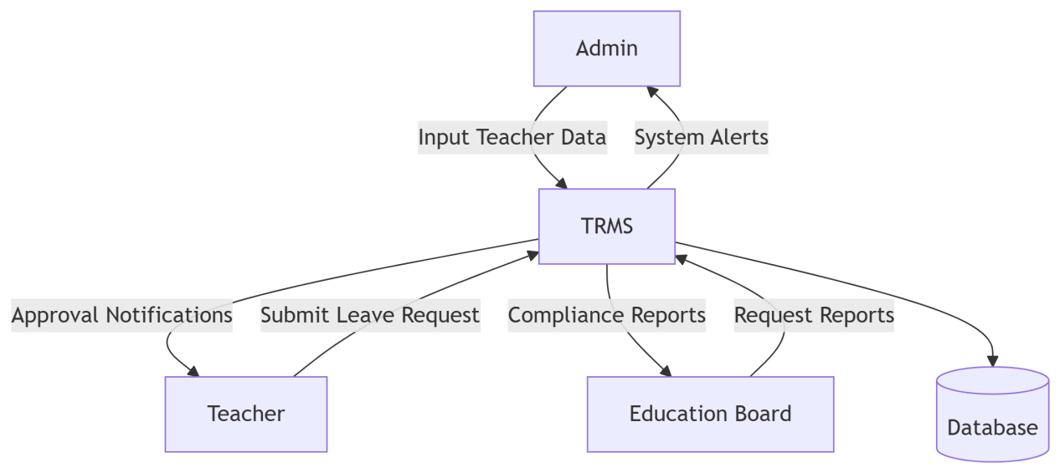

Figure 3 1 Data Flow Diagram of the Current System, Author, (2025)

### 3.4.2 Context Diagram

A context diagram was constructed to represent the system as a single process and its interaction with external entities such as school administrators, the Ministry of Education, and teachers. This diagram provided a macro-level overview of the system’s environment and its data exchange points.

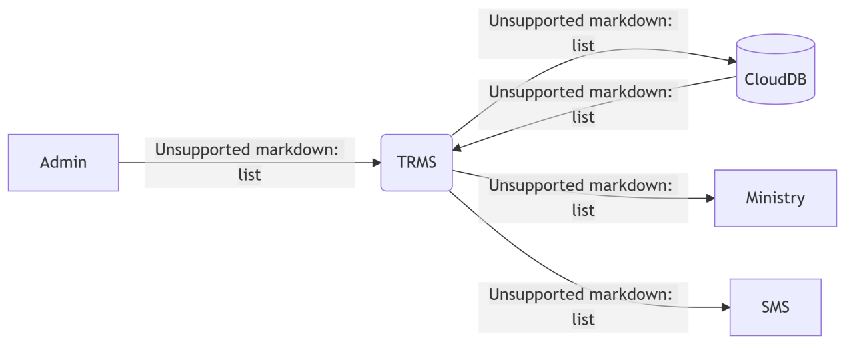

Figure 3 2 Context Diagram of the Current System, Author, (2025)

#### 

## 3.5 Methodology for System Design of the Proposed System

### 3.5.1 Data Flow Diagram

Enhanced DFDs were created to model the improved processes in the proposed TRMS. These diagrams demonstrated how data would move through the system once automated, showing clear, structured pathways from input to output.

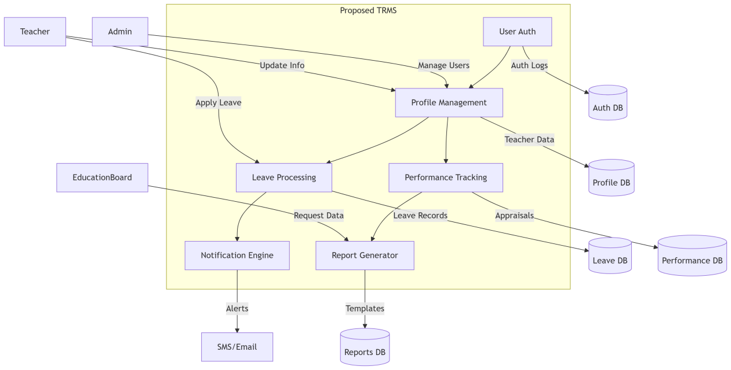

Figure 3 3 Data Flow Diagram of the Proposed System, Author, (2025)

##### 

## 3.5.2 Flowcharts

Flowcharts were developed for each major system process including teacher registration, leave request submission, performance appraisal, and promotion tracking. These diagrams clarified the logical sequence of operations and decision-making paths.

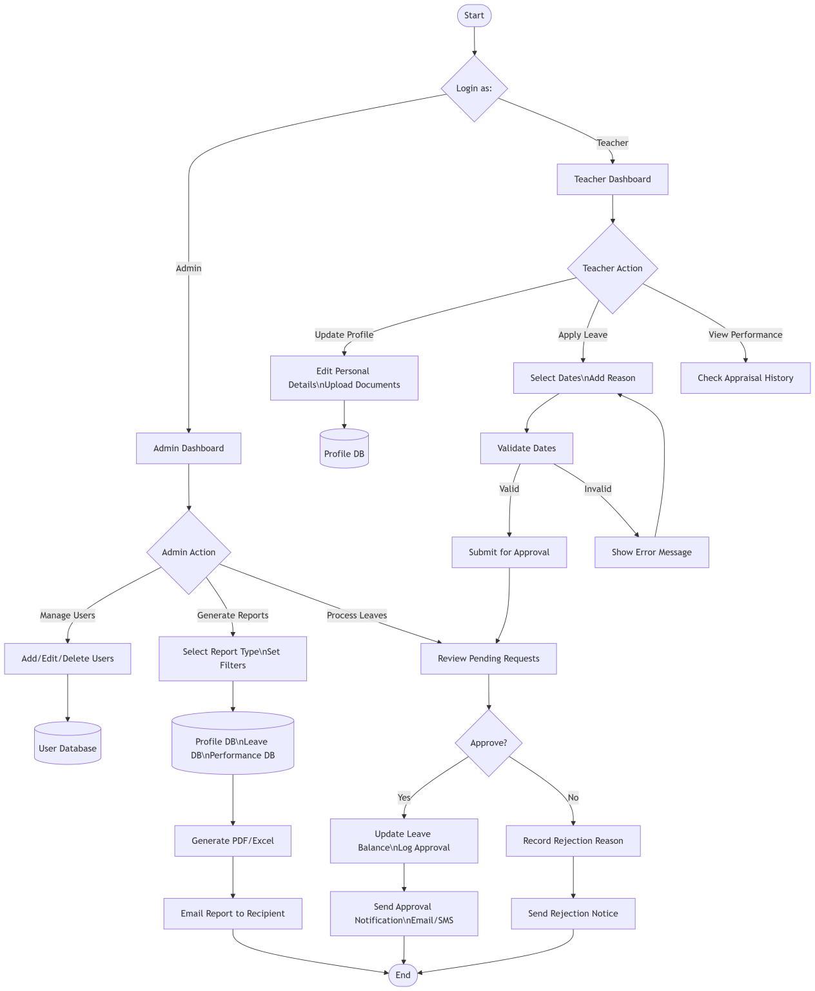

Figure 3 4 Flowcharts Diagrams of the Proposed System, Author, (2025)

##### 

### 3.5.3 Sequence Diagram

Sequence diagrams illustrated the chronological order of interactions between system entities. For example, the diagram for user authentication showed the sequential exchange of data between the login form, authentication module, and the user database.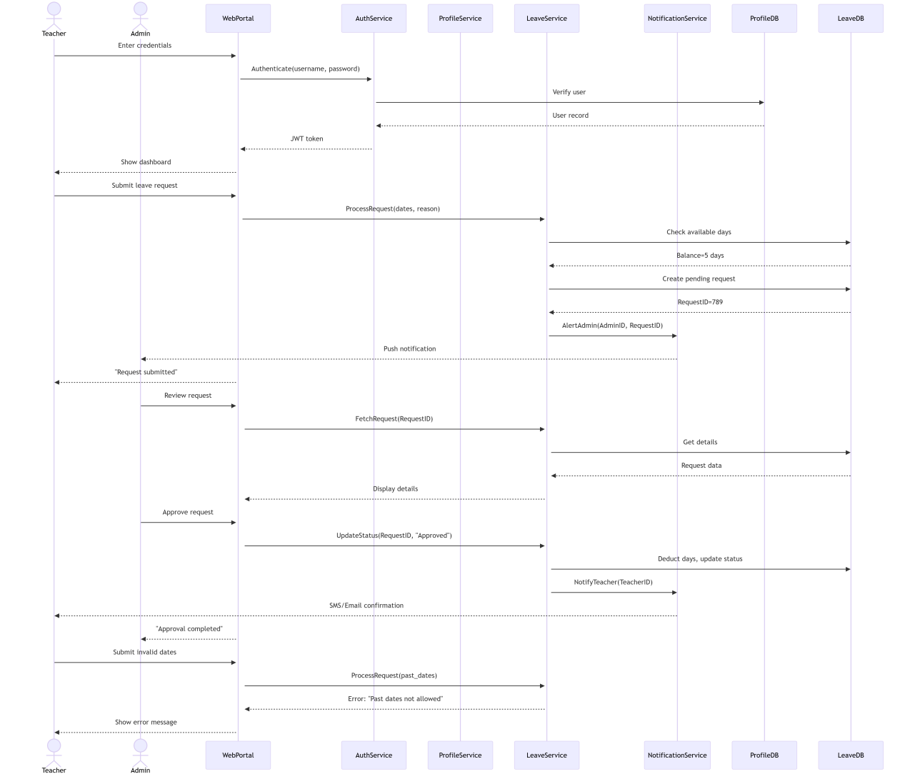

Figure 3 5 Sequence Diagram of the Proposed System, Author, (2025)

### 

### 3.5.4 Collaboration Diagrams

Collaboration diagrams were used to show relationships and data exchanges between various system components during key processes. These diagrams complemented sequence diagrams by focusing on the structure of system interactions.

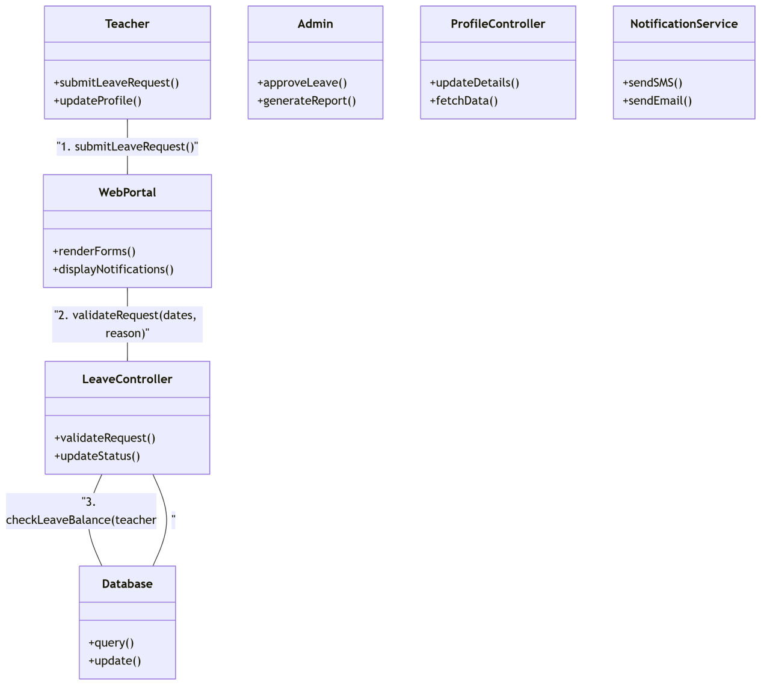

Figure 3 6 Collaboration Diagrams of the Proposed System, Author, (2025)

### 

### 3.5.5 Use Case Diagrams

Use case diagrams modeled the functionalities of the system from the user’s point of view. Actors such as the administrator, teacher, and system auditor were identified along with their respective use cases such as ‘add teacher record’, ‘update appraisal’, and ‘generate report’.

### 3.5.7 Early System Prototypes (I/O Design)

As part of the system development life cycle, early-stage prototypes focusing on input and output (I/O) design were created to visualize how users would interact with the Teacher Record Management System (TRMS). The design and prototyping process was carried out using Figma, a popular collaborative design tool that enabled the creation of wireframes and mockups without requiring actual backend functionality at this stage.

The goal of this phase was to develop user-friendly, intuitive, and context-appropriate interfaces that would reflect the core functionalities of the system. The wireframes included a range of essential system screens such as the user login interface, teacher dashboard, record entry forms, promotion and leave tracking interfaces, and report generation panels. Each screen was designed with usability and clarity in mind, incorporating clearly labeled buttons, navigation menus, dropdowns, search bars, and form fields relevant to the respective user roles (e.g., administrators, HR officers, and teachers).

Special attention was paid to input screens, as these are where users would spend significant time entering and updating teacher information. Forms were grouped logically to avoid clutter, with input validation hints and required fields clearly marked to minimize data entry errors. On the other hand, the output screens focused on data visualization and reporting, enabling users to easily generate and interpret information such as staff distribution, qualification summaries, leave history, and appraisal results. These features were aimed at supporting institutional planning and decision-making.

Once the preliminary wireframes were developed, user feedback sessions were conducted. Select stakeholders including school administrators, ICT staff, and a few teachers were invited to review the prototypes and provide input on usability, navigation flow, and interface layout. Their feedback was documented and used to guide iterative improvements to the design. For example, suggestions were made to simplify the dashboard layout, reduce the number of clicks required to update a teacher record, and provide better tooltips for first-time users. By engaging users early in the design process, the prototype phase not only validated initial system requirements but also ensured that the final system would be more aligned with real-world user expectations and workflows. These prototypes served as a critical communication tool between developers and stakeholders, reducing the likelihood of misinterpretation and rework during later development stages.

### 3.5.8 Design of the User Interface

The design of the user interface (UI) for the Teacher Record Management System (TRMS) was guided by core principles of simplicity, responsiveness, accessibility, and usability, ensuring that users could interact with the system efficiently and with minimal learning curve. The primary objective was to create a clean, well-structured interface that accommodates users with varying levels of technical expertise, particularly within educational institutions where ICT literacy may vary widely among staff. To achieve this, the development process adopted HTML5 and CSS3 for the structural and stylistic components of the interface. HTML5 provided a semantic and well-organized markup structure that enhanced both readability and maintainability of the code. CSS3 was used extensively to style the interface elements, allowing for the implementation of modern, visually appealing designs such as cards, buttons, form fields, tables, and layout grids. These styles contributed to a professional appearance while preserving clarity and legibility.

To enhance cross-device compatibility and responsiveness, the Bootstrap framework was integrated into the design process. Bootstrap enabled the use of prebuilt responsive classes and grid systems, allowing the interface to adjust fluidly across different screen sizes from desktops and laptops to tablets and smartphones. This responsiveness was particularly important given the need for remote access to the system, as outlined in the project scope. Teachers and administrators could access the platform from various devices without encountering usability issues or distorted layouts. The UI was further enhanced with interactive elements such as models for data entry, collapsible menus for navigation, and alert messages for real-time system feedback (e.g., successful data submission or error notifications). Icons and tooltips were used where appropriate to support user understanding and minimize cognitive load. In terms of accessibility, the design adhered to basic Web Content Accessibility Guidelines (WCAG). This included maintaining sufficient contrast ratios for text, using alt attributes for images, and ensuring that all interactive components were keyboard-navigable. These considerations aimed to make the platform inclusive for users with visual or motor impairments.

User-centered design practices were maintained throughout the process, incorporating feedback from early prototype evaluations (as discussed in Section 3.5.7). Based on user comments, adjustments were made to streamline workflows—for example, minimizing the number of fields on key forms, grouping related data into tabs, and reducing the number of clicks required to perform common tasks like updating a teacher’s appraisal record or generating reports. Overall, the user interface was designed to be minimalistic yet functionally rich, focusing on delivering a smooth, intuitive experience that empowers users to perform their administrative tasks effectively, regardless of their location or device.

### 3.5.9 Design of the Database

The design of the database for the Teacher Record Management System (TRMS) was a critical component of the system architecture, as it formed the foundation for secure, reliable, and efficient data storage and retrieval. The database was developed using MySQL, a widely used relational database management system (RDBMS) known for its robustness, scalability, and support for structured query language (SQL). MySQL was chosen due to its compatibility with web technologies, its open-source nature, and its ability to handle moderate-to-large datasets effectively all of which are ideal for the deployment of systems within educational institutions.

The data modeling phase began with the identification of key entities relevant to the teacher record management domain. These entities included, but were not limited to, Teachers, Appraisals, Promotions, LeaveRecords, Training, and Users. Each entity was carefully analyzed to determine the appropriate attributes needed for the TRMS to function as intended. For instance, the Teachers table captured detailed biodata including name, national ID, date of birth, contact details, and professional qualifications. The Appraisals table recorded evaluation scores, appraisal dates, feedback summaries, and reviewer identities. Similarly, LeaveRecords maintained a history of all leave applications, including types of leave, approval status, and return dates. To ensure clarity in the relationships between these entities, Entity-Relationship Diagrams (ERDs) were developed. These diagrams served as visual representations of how different tables in the database relate to one another. For example, a one-to-many relationship was established between the Teachers table and both the Appraisals and Promotions tables, indicating that each teacher could have multiple appraisal records and promotion entries over time. Likewise, foreign keys were used to enforce referential integrity between related tables.

To improve the efficiency, integrity, and scalability of the database, normalization techniques were applied rigorously. The schema was normalized up to the third normal form (3NF), which ensured the elimination of data redundancy and minimized the potential for update anomalies. This process involved decomposing complex tables into smaller, more manageable tables and removing any transitive or partial dependencies. As a result, the database structure became more streamlined and consistent, which ultimately enhances performance and data integrity.

Indexing strategies were also considered during the design to facilitate faster query execution, especially for frequently accessed data such as teacher profiles and leave history. Sensitive information, such as user login credentials and appraisal data, was safeguarded through encryption mechanisms and access controls, aligning with the security requirements identified earlier in the specification phase. In summary, the TRMS database was designed with a strong emphasis on data integrity, relational accuracy, performance optimization, and scalability. The design supports both current institutional needs and potential future enhancements, such as integration with payroll systems or national education databases.

## 3.6 Methodology for System Implementation, Back end, Front end and Database

### 3.6.1 Back-End Technologies

The back-end development of the Teacher Record Management System (TRMS) was focused on creating a secure, efficient, and responsive server-side infrastructure that could support all core functionalities of the application. For this purpose, PHP (Hypertext Preprocessor) was selected as the primary programming language for implementing the server-side logic. PHP is a widely adopted, open-source scripting language known for its seamless integration with web technologies and relational databases, particularly MySQL, which was also used in the system's data layer.

The PHP-based back-end was responsible for handling a range of crucial operations that facilitate user interaction with the system while ensuring data integrity and security. These operations included session management, user authentication and authorization, and CRUD (Create, Read, Update, Delete) functionalities for managing teacher records, leave applications, performance appraisals, promotions, and training history. One of the core reasons for choosing PHP was its built-in support for interacting with MySQL databases, which simplified the development process. PHP’s MySQL and PDO (PHP Data Objects) libraries were utilized to establish secure and stable database connections, perform parameterized queries, and prevent SQL injection attacks. These mechanisms ensured that user-submitted data could be validated and stored securely, especially for sensitive information such as login credentials and teacher evaluations.

In addition, PHP facilitated the implementation of role-based access control (RBAC). Different access privileges were assigned to various user roles (e.g., administrators, HR personnel, department heads, and teachers), allowing the system to restrict certain operations based on user permissions. This feature ensured that only authorized personnel could perform tasks such as modifying teacher records or accessing confidential appraisals. To maintain smooth interactions between the front-end and the database, AJAX (Asynchronous JavaScript and XML) was incorporated in conjunction with PHP. This allowed certain operations—such as form submissions, data updates, and report generation to occur asynchronously, enhancing the system’s responsiveness and overall user experience.

Moreover, the modular nature of PHP allowed for the organization of back-end code into reusable components and functions, which improved maintainability and made future expansion easier. Security considerations were also embedded throughout the PHP scripts, including input sanitization, password hashing using algorithms such as bcrypt, and the use of server-side validation to supplement client-side checks. In summary, PHP was instrumental in delivering a robust and flexible back-end for the TRMS. Its compatibility with MySQL, ease of deployment on standard web servers, and rich ecosystem of libraries and tools made it an ideal choice for developing a scalable and secure administrative system for educational institutions.

### 3.6.2 Front-End Technologies

The front-end of the Teacher Record Management System (TRMS) was developed using a suite of modern web technologies aimed at delivering a responsive, user-friendly, and visually coherent interface. The technologies employed included HTML5, CSS3, JavaScript, and Bootstrap, each playing a distinct role in ensuring that the application was both functional and aesthetically pleasing across multiple devices and screen sizes.

HTML5 served as the structural foundation of the application. It was used to define the layout and semantics of various web pages, including login screens, teacher dashboards, data entry forms, and reporting interfaces. HTML5 tags enhanced accessibility and made the interface more understandable for both browsers and assistive technologies, promoting compliance with web standards and best practices. CSS3 was employed to style the HTML elements, providing a clean and professional look. CSS3 features such as transitions, flexbox layouts, and media queries allowed for precise control over the presentation and positioning of elements. This ensured that the user interface remained consistent and visually appealing across a wide range of devices, including desktops, tablets, and smartphones.

To further enhance responsiveness and consistency in design, Bootstrap, a popular front-end framework, was integrated into the system. Bootstrap offered a wide range of pre-built components such as navigation bars, form elements, buttons, and modals. Its powerful grid system was leveraged to create fluid layouts that automatically adapted to various screen resolutions. This was particularly important in ensuring that school personnel, who might access the system using different devices, experienced seamless interactions regardless of platform.

JavaScript added interactivity and dynamism to the user interface. Client-side scripts were used to perform tasks such as dynamic form validation, conditional content display, and interactive elements like dropdown menus and modals. JavaScript also handled form field validations in real-time, providing immediate feedback to users and reducing input errors before data was sent to the server. Additionally, JavaScript was used in conjunction with AJAX (Asynchronous JavaScript and XML) to facilitate real-time data exchange between the client and the server without requiring full page reloads. This enhanced the user experience by allowing users to fetch teacher records, submit updates, and generate reports dynamically and efficiently.

To improve maintainability and user experience, best practices such as code modularization, semantic markup, and accessible design standards were followed throughout the front-end development process. Efforts were also made to ensure compatibility with popular browsers such as Chrome, Firefox, and Microsoft Edge. In summary, the front-end technologies utilized in the TRMS were carefully chosen and implemented to ensure a responsive, accessible, and interactive interface. Together, they enabled efficient data entry, intuitive navigation, and real-time interaction, thereby supporting the overall goal of enhancing administrative processes in educational institutions.

### 3.6.3 Database Technologies

The Teacher Record Management System (TRMS) employed MySQL as its core relational database management system (RDBMS). MySQL was chosen due to its proven reliability, scalability, strong support for transactional operations, and its compatibility with PHP, the selected back-end programming language. As an open-source platform, MySQL also aligned well with the project's goal of creating a cost-effective and easily deployable solution, particularly for resource-constrained educational institutions.

The database served as the backbone of the TRMS, storing all essential records and ensuring data consistency, accuracy, and security. It was designed to manage a wide range of teacher-related data, including personal biodata, academic qualifications, teaching experience, promotion history, leave records, appraisal results, training participation, and system user credentials. To achieve this, a normalized data model was adopted during the design phase to eliminate redundancy and improve data integrity. Tables were logically organized and interconnected using foreign key constraints, forming a relational structure that mirrored real-world relationships between various data entities. In addition to standard SQL queries, the system utilized stored procedures to encapsulate business logic and standard operations such as inserting, updating, or deleting teacher records. Stored procedures offered performance benefits by reducing the amount of information sent between the application and the database server. They also enhanced security by limiting direct access to underlying data structures.

To further automate routine actions and enforce critical business rules, triggers were implemented within the database. For example, a trigger could automatically log a timestamp when a teacher’s record was updated or generate an alert if certain performance appraisal thresholds were not met. These mechanisms helped maintain data consistency while minimizing the risk of manual errors. The database also featured role-based access control mechanisms, supported at the database level. Different users such as HR personnel, department heads, and system administrators were assigned specific privileges that restricted what data they could view or modify. This aligned with the system’s security requirements and ensured that sensitive data was accessed only by authorized personnel.

Regular database backups were scheduled to protect against data loss, and indexes were applied to frequently queried fields to enhance performance, especially when generating real-time reports and searching through large datasets. In conclusion, MySQL provided a robust and flexible foundation for the TRMS, enabling secure, efficient, and scalable storage of teacher records. Its integration with application-level logic through stored procedures, triggers, and access control made it an ideal choice for supporting the complex data handling needs of educational institutions.

## 3.7 Methodology for System Testing; Testing Plan, Testing Techniques

### 3.7.1 Methodology for System Testing

System testing involved both white-box and black-box techniques. White-box testing checked internal logic and code paths, while black-box testing validated system behavior against user expectations.

### 3.7.2 Testing Plan

A structured and comprehensive testing plan was formulated to guide the evaluation and validation of the Teacher Record Management System (TRMS). The primary aim of the testing plan was to ensure that all system components functioned correctly, efficiently, and securely in accordance with the specified requirements. The plan served as a roadmap for the testing process, outlining key elements such as testing objectives, test environments, resources required, types of testing to be conducted, defined test cases, expected outcomes, and timelines for execution.

The testing objectives were clearly defined to include verification of system functionalities, identification of bugs or inconsistencies, assessment of performance under different conditions, and confirmation that user requirements were met. These objectives provided a benchmark against which the quality and reliability of the TRMS could be measured. The plan detailed the testing resources required, including hardware (such as computers or mobile devices), software tools (e.g., browsers, database clients), and human resources (such as developers, testers, and sample end users). Testing was scheduled to take place in both development and real-world environments to simulate actual user conditions as closely as possible.

A set of test cases was developed based on the functional and non-functional requirements of the system. Each test case described a specific scenario, including input data, step-by-step execution procedures, and the expected output. Examples included testing user login functionality, data entry into teacher records, leave request approval workflows, and generation of performance appraisal reports. These test cases were categorized into different testing types such as unit testing, integration testing, system testing, and user acceptance testing (UAT).

The expected outcomes for each test case were documented to serve as reference points during execution. Any deviation between actual and expected results was flagged for further investigation and debugging. This process ensured that all modules were thoroughly evaluated for accuracy and completeness. The testing schedule was designed to align with the project timeline and development milestones. Early testing phases focused on isolated components, while later phases emphasized system-wide performance and user interaction. Testing was iterative in nature, allowing for feedback-driven improvements at each stage.

Additionally, risk-based testing principles were applied to prioritize critical system functionalities such as authentication, data storage, and access control ensuring that the most vital features were validated first. Documentation of test results and issues encountered was maintained to inform future updates and maintenance planning. In summary, the testing plan played a crucial role in assuring the quality, functionality, and readiness of the TRMS. It established a disciplined approach to software validation, promoting confidence in the system’s performance before deployment in a real educational environment.

### 3.7.3 Testing Techniques

Testing techniques are essential for ensuring that a software system meets its intended functionality, performs reliably, and delivers a secure and user-friendly experience. In the context of the Teacher Record Management System (TRMS), a combination of structured and targeted testing methods was employed to assess the system’s performance, functionality, and user interaction across different modules and environments. The use of diverse testing approaches helped identify and eliminate potential defects early, thereby enhancing the system’s overall quality and robustness.

The first testing technique employed was unit testing. This involved testing individual components or modules of the TRMS in isolation to verify that each one worked correctly on its own. For instance, units such as the login function, data input forms, and CRUD (Create, Read, Update, Delete) operations for teacher records were tested separately to ensure they behaved as expected under normal and edge-case conditions. Unit testing allowed the development team to detect and fix bugs at the earliest stage of development, significantly reducing debugging costs later. Next, integration testing was conducted to assess the interaction between different modules within the system. This technique verified that data flowed correctly between modules such as the teacher biodata records, performance appraisal module, and the leave management system. It ensured that the components, once combined, communicated without error and that any dependencies between modules were handled properly.

Following integration testing, system testing was performed. This involved evaluating the TRMS as a complete and integrated system, checking whether all the functional and non-functional requirements were met. Test cases simulated real-world usage scenarios to verify that the system responded accurately, regardless of the sequence or type of operations performed. System testing covered areas like user login, role-based access control, form submissions, data validations, and report generation. To further ensure the system met stakeholder expectations, User Acceptance Testing (UAT) was carried out. This technique involved real users such as teachers, school administrators, and ICT coordinators interacting with the system to perform everyday tasks. Feedback from UAT was instrumental in validating the system’s usability, identifying minor issues that were not evident during earlier technical tests, and gathering suggestions for refinement before deployment.

In addition to functional testing, performance testing was conducted to evaluate how the system handled load under stress. This involved simulating multiple users accessing and using the system simultaneously to assess its speed, responsiveness, and stability. Results from performance testing confirmed whether the TRMS could support concurrent users without delays or crashes, which is especially critical in schools with high staff numbers. Security testing was also a priority. This technique focused on ensuring the protection of sensitive data, particularly personal and professional information of teachers. Tests were conducted to check for vulnerabilities such as unauthorized data access, SQL injection, and weak password handling. Proper encryption protocols and access restrictions were verified to ensure compliance with data protection standards.

Finally, regression testing was performed throughout the development lifecycle. After implementing new features or fixing bugs, regression testing helped ensure that existing functionalities were not inadvertently affected by recent changes. It provided confidence that the system remained stable and reliable as it evolved. In summary, a comprehensive mix of testing techniques ranging from unit and integration testing to user acceptance and security testing was applied in the development of the TRMS. These methods ensured that the system was functionally complete, reliable under varying conditions, secure, and user-friendly, making it ready for deployment in real-world educational institutions.

**3.8 Methodology for System Deployment**

The deployment of the Teacher Record Management System (TRMS) followed a carefully structured and phased approach to ensure a smooth transition from the existing manual or semi-digital processes to the new automated system. The methodology was designed to minimize disruptions, address unforeseen technical or user-related issues, and promote stakeholder confidence in the new platform.

The first phase of deployment involved setting up the system in a test environment. This controlled setup mimicked a real-world school IT environment but allowed developers and testers to observe how the system behaved under simulated conditions. The objective was to identify any hidden bugs, performance issues, or compatibility challenges that may not have been captured during earlier development and testing stages. This phase also enabled refinements to configuration settings, user interface elements, and database structures based on practical insights.

After successful validation in the test environment, the project moved into the pilot deployment phase. A medium-sized educational institution was selected for this purpose, based on its representative characteristics and willingness to participate in the trial. The pilot site served as a microcosm for broader deployment, allowing the development team to monitor the system in an actual operational setting. Key focus areas during the pilot included user interaction with the system, data migration processes, system response times, and ease of access. Feedback from administrators, teachers, and ICT personnel was collected through observation and short surveys to identify usability issues and recommend enhancements.

Following the successful execution and evaluation of the pilot program, the full-scale deployment phase was initiated. This involved rolling out the TRMS to the intended target schools that fit the criteria defined during the research scope typically institutions with 50 to 100 teachers. The deployment process was guided by a timeline that included stages for installation, data import, testing, training, and go-live activities. Adequate coordination was ensured among the project team, school IT personnel, and administrative staff to support the transition.

To support end users, comprehensive deployment documentation was developed and distributed. This included step-by-step installation manuals, user guides, and system administration references. These documents covered everything from how to log in and enter data to managing backups and resetting passwords. The documentation was written in simple, non-technical language with visual aids such as screenshots and diagrams to help users understand each function easily.

Moreover, training sessions were conducted to familiarize users with the system’s functionality. These sessions included hands-on demonstrations and interactive exercises, allowing users to practice navigating the system, entering records, generating reports, and addressing common errors. Special attention was given to role-based training, ensuring that different user groups such as administrators, teachers, and department heads understood the specific features relevant to their roles. In conclusion, the deployment methodology adopted for the TRMS emphasized gradual implementation, real-user feedback, and sufficient training and documentation to foster system adoption. This approach not only reduced the risk of technical failures but also promoted user acceptance and ensured a successful and sustainable system launch.

## 3.9 Chapter Summary

This chapter has elaborated on the research methodologies utilized in the study and development of the TRMS. From literature review to system design, implementation, and deployment, each step was executed with the aim of delivering a reliable and user-oriented solution. The methodologies adopted ensured thorough analysis, stakeholder engagement, and adherence to best practices in system development. The next chapter will present and discuss the results of the implementation phase, showcasing the system’s features and functionalities.

# **CHAPTER FOUR**

# **SYSTEM ANALYSIS**

## 4.1 Chapter Introduction

System analysis is a fundamental phase in the software development life cycle. This chapter provides a comprehensive analysis of the existing teacher record management system and outlines its strengths and weaknesses. Additionally, a feasibility study was conducted to evaluate the practicality of developing a new system based on technical, economic, and operational aspects. Further, a detailed analysis of data input and output processes is presented along with the current system's logic and process design, visualized using flowcharts, context diagrams, and data flow diagrams (DFDs).

## 4.2 Description of the Current System, Its Strengths, and Weaknesses

### 4.2.1 Strengths of the Current System

Despite its limitations, the current manual teacher record management system possesses several notable strengths that contribute to its continued use in many educational institutions. One of its primary advantages is simplicity the system is easy to understand and operate, requiring no prior technical knowledge or specialized training. This makes it accessible to all members of staff, regardless of their IT proficiency. Another significant benefit is the low cost of implementation and maintenance. Since the system does not rely on licensed software or expensive hardware, schools only incur minimal costs related to stationery, physical storage, and occasional printing.

Additionally, the manual approach offers the benefit of maintaining a paper trail. Physical documents serve as tangible evidence that can be retrieved and presented when needed, which is particularly useful in situations that demand official verification or legal accountability. Many administrators still value the ability to hold and review hard-copy records during audits or administrative reviews. Moreover, the system allows for immediate use, as it does not require the setup of digital infrastructure or waiting for software installations. Teachers and school managers can begin documenting data instantly with just a pen and file, making the process highly flexible and instantly deployable in low-resource environments. These strengths illustrate why, despite its drawbacks, the manual system continues to serve as a fallback solution in many schools.

### 4.2.2 Weaknesses of the Current System

While the manual teacher record management system has certain advantages, it is plagued by several critical weaknesses that hinder its effectiveness, especially in modern educational environments. One of the most pressing issues is the risk of data loss. Paper records are highly vulnerable to physical damage from fire, water, pests, or simply wear and tear over time. Misplacement or accidental destruction of files can result in the permanent loss of important teacher information, which is difficult if not impossible to recover.

Another major drawback is the inefficiency associated with manual systems. Retrieving, updating, or cross-referencing information often requires sifting through piles of documents, which consumes valuable time and administrative resources. This inefficiency becomes even more pronounced during peak periods such as performance evaluations, promotions, or audits. Additionally, human error is a constant risk. Mistakes in data entry, misfiling of records, and duplication of entries are common and can lead to inconsistencies that compromise the reliability of the information being managed.

Security is also a significant concern. Paper records offer little protection against unauthorized access; they can be read, copied, or stolen without leaving any trace. Unlike digital systems, manual files lack access control mechanisms such as passwords or encryption, making them unsuitable for storing sensitive personal data. Lastly, the manual approach suffers from limited scalability. As the volume of teacher data increases over time, managing physical files becomes increasingly unmanageable. Storage space constraints, difficulty in tracking historical records, and the inability to generate reports dynamically make the system unsustainable for long-term use. These limitations highlight the urgent need for a digital solution that can enhance accuracy, security, and operational efficiency.

## 4.3 Feasibility Study and Its Conclusion

To determine whether the proposed automated Teacher Record Management System is viable, a feasibility study was conducted. The study included technical, economic, and operational analyses.

### 4.3.1 Technical Feasibility

From a technical perspective, the implementation of the proposed Teacher Record Management System (TRMS) is highly feasible. The system is designed to run on widely available and cost-effective technologies, including PHP for server-side scripting, MySQL for database management, and HTML/CSS for front-end development. These technologies are open-source and have extensive community support, making them accessible even for institutions with limited budgets. Moreover, they require minimal licensing fees, which aligns well with the financial constraints of many educational institutions.

In terms of hardware requirements, the system can operate efficiently on standard computing devices such as desktop computers and laptops that are already available in many schools. This eliminates the need for specialized or high-performance hardware, thus reducing implementation costs. Additionally, with increasing access to the internet across educational institutions especially those in urban and peri-urban areas system deployment and remote accessibility are well-supported. Cloud-based hosting options or local server installations can be considered depending on the available infrastructure, further enhancing flexibility.

Furthermore, the TRMS has been designed with scalability and compatibility in mind, ensuring it can run on both Windows and Linux-based environments. The system’s lightweight architecture minimizes processing power requirements, allowing smooth operation even on older machines. Given these considerations, the technological environment in most educational institutions is sufficient to support the successful deployment, operation, and maintenance of the proposed TRMS without major technical obstacles.

**4.3.2 Economic Feasibility**

The proposed Teacher Record Management System (TRMS) is economically feasible for implementation in most educational institutions, particularly in resource-constrained environments. The overall cost of development, deployment, and maintenance is relatively low, especially when compared to the long-term advantages it offers in terms of operational efficiency and data accuracy. Since the system is built using open-source technologies such as PHP, MySQL, HTML, CSS, and Bootstrap, there are no licensing fees required for software acquisition. This drastically reduces the initial setup costs and makes the solution accessible even to institutions operating on tight budgets.

Furthermore, most schools already have basic Information and Communication Technology (ICT) infrastructure in place, such as computers, internet access, and basic networking equipment. This means that there is little to no need for additional hardware investment, making the implementation cost-effective. In cases where upgrades are needed, the required enhancements are minimal and affordable. The system is also designed with cost-efficiency in mind for future maintenance and scalability. It requires only basic technical knowledge to operate and maintain, eliminating the need for expensive technical support or specialized personnel. Training materials and user documentation are provided, enabling school staff to manage the system with minimal external support.

From a long-term perspective, the return on investment (ROI) is significantly high. By automating the teacher record management process, schools can save time, reduce administrative workload, minimize errors, and improve data security. This leads to more informed decision-making, enhanced compliance with reporting requirements, and better overall management of teaching staff. Therefore, the economic feasibility of the TRMS not only ensures affordability but also promises sustainable benefits for educational institutions in the long run.

### 4.3.3 Operational Feasibility

From an operational standpoint, the proposed Teacher Record Management System (TRMS) is highly feasible and well-aligned with the daily functions and routines of educational institutions. Preliminary engagement with key stakeholders including head teachers, school managers, ICT coordinators, and teaching staff revealed a positive attitude and a strong willingness to adopt a digital solution for managing teacher records. Many of these stakeholders expressed frustration with the inefficiencies of the current manual system and indicated a clear readiness for change, especially if the new system would improve accuracy, reduce workload, and streamline access to important records.

One of the key advantages contributing to operational feasibility is the system’s user-friendly design. The interface is intuitive, with simple navigation and logically organized modules tailored to the tasks of different user roles such as administrators, department heads, and teachers. This minimizes the learning curve and makes the system easy to adopt even for users with limited technical experience. Training requirements are modest and manageable, as most of the operations such as entering teacher biodata, tracking appraisals, or generating reports are straightforward and well-documented in the user manual and training materials provided.

Moreover, the system incorporates role-based access control, which helps ensure that each user interacts only with the data and functions relevant to their responsibilities. This clear delineation of roles not only enhances security but also simplifies workflow integration, reducing confusion and overlap in responsibilities. The system is designed to complement existing school processes rather than replace them entirely, allowing for a smooth transition and minimal disruption to ongoing activities. Overall, the operational feasibility of the TRMS is solid. With stakeholder support, minimal training overhead, and an accessible design, the system is expected to integrate seamlessly into the existing structure of school operations and significantly improve the management of teacher records.

**4.3.4 Conclusion of the Feasibility Study**

All aspects of the feasibility study indicate that the proposed system is practical, cost-effective, and valuable to the institution. The conclusion is that development should proceed as planned.

## 4.4 Data Input/output Analysis

### 4.4.1 Data Input Analysis

The existing method of data input in most educational institutions is predominantly manual, involving the use of paper-based forms and logbooks to capture teacher-related information. This traditional approach requires school staff to physically write down various data points such as personal and professional details of teachers, attendance records, types and durations of leave taken, appraisal results, performance reviews, promotions, and any disciplinary actions. While straightforward, this method is highly susceptible to errors arising from human oversight, such as miswriting, incomplete entries, or illegible handwriting. Moreover, the manual nature of the process makes it significantly time-consuming, particularly when dealing with a large volume of records or attempting to retrieve and update existing data.

One of the most critical limitations of this system is the lack of standardized validation, which often leads to inconsistencies and inaccuracies in the recorded data. For instance, important fields might be skipped or filled out incorrectly, resulting in incomplete or unreliable records. This compromises the quality of decision-making and hampers the efficiency of administrative operations.

To address these challenges, the proposed Teacher Record Management System (TRMS) will introduce digital data entry forms with built-in field validation mechanisms. These forms will guide users to input data correctly and completely, ensuring that all required fields are filled in before submission. For example, fields such as national ID numbers, email addresses, and dates will be checked for formatting accuracy, while dropdown menus and radio buttons will be used to reduce entry errors in selection-based inputs. The digital nature of the system will not only reduce the risk of human error but also significantly speed up the data entry process, thereby improving the overall efficiency, consistency, and reliability of teacher data management across institutions.

### 4.4.2 Data Output Analysis

In the current manual system used by many educational institutions, data output is generated through labor-intensive processes that involve manually compiling and formatting records into various reports. Common outputs include monthly attendance sheets, teacher appraisal reports, leave summaries, and general staff listings. These reports are usually prepared by administrative staff using information collected from multiple paper files and logbooks, a task that is not only time-consuming but also prone to inconsistencies and human error. The lack of a standardized format for generating these documents often results in varied report structures, which can make comparisons, audits, and record tracking difficult over time.

Furthermore, the manual generation of reports poses challenges when updates or revisions are needed, as staff must revisit original documents and recreate the outputs delaying decision-making and increasing the workload. In cases where multiple reports are required simultaneously (e.g., during inspections or planning meetings), the output process becomes even more strained, with a high likelihood of inaccuracies and omissions.

The proposed Teacher Record Management System (TRMS) aims to resolve these inefficiencies by introducing automated data output functionality. The system will be designed to generate a wide range of reports such as monthly attendance summaries, performance evaluations, leave balances, and staff directories automatically, based on the data entered into the system. Reports will follow standardized templates to ensure consistency in presentation, and users will be able to customize outputs based on specific parameters such as date ranges, departments, or teacher roles. Automation will not only reduce the time and effort required to produce these documents but will also improve accuracy, enhance readability, and enable quick access to up-to-date information. Additionally, outputs can be exported in various formats such as PDF, Excel, or printed copies, making the system both flexible and user-friendly for administrative purposes.

## 

## 4.5 Process Logic Design of the Current System

The existing teacher record management process in many schools operates on a linear and manual workflow. When a new entry such as teacher biodata, leave request, or performance appraisal is required, a staff member must fill out the necessary forms by hand. These physical forms are then submitted to an administrator, who manually reviews the information for completeness and accuracy. Once approved, the documents are either filed away in cabinets or recorded in logbooks. Retrieving any information at a later stage requires physically locating the file or logbook, manually searching for the relevant data, and reviewing it by hand. This process, while straightforward, is time-consuming, error-prone, and inefficient especially when dealing with a large volume of records.

The linear nature of this system creates bottlenecks at various stages. Delays are common, particularly when administrators are overwhelmed with paperwork or when documents are misplaced. Furthermore, the absence of a structured approval flow or version control increases the risk of outdated information being referenced, leading to inconsistencies and potential miscommunication. Limited access control also means that sensitive information may be handled by unauthorized personnel, further compromising the system’s reliability and security.

To address these issues, the proposed Teacher Record Management System (TRMS) introduces a more advanced and automated process logic design. Key activities such as auto-saving of entries and version control will be incorporated to ensure that the most recent updates are preserved without the risk of data loss. Role-based data access will ensure that only authorized personnel can view or edit specific categories of information, thus enhancing data confidentiality and accountability. In addition, systematic approval workflows will be integrated into the platform, allowing administrators to review and approve submissions digitally, with the system tracking every stage of the process. These improvements will streamline operations, reduce manual workload, and significantly improve the accuracy, consistency, and responsiveness of teacher record management within educational institutions.

### 4.5.1 Flowcharts

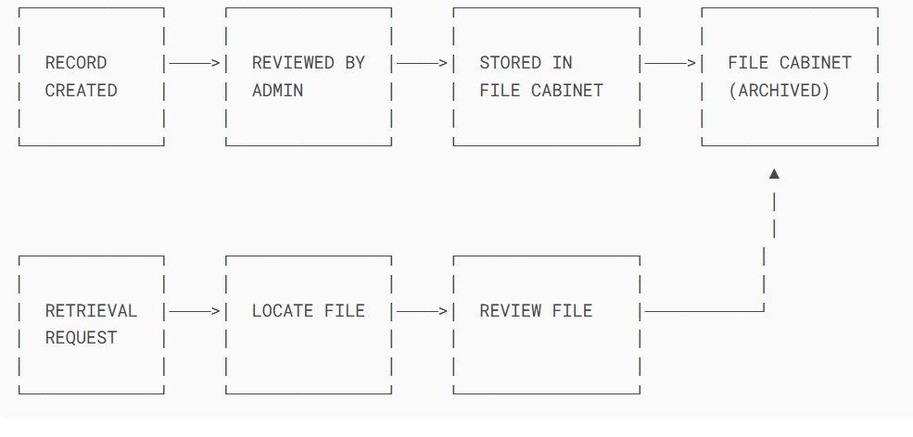

Figure 4 1 Flowcharts of the Current System, Author, (2025)

##### 4.5.2 Context Diagrams

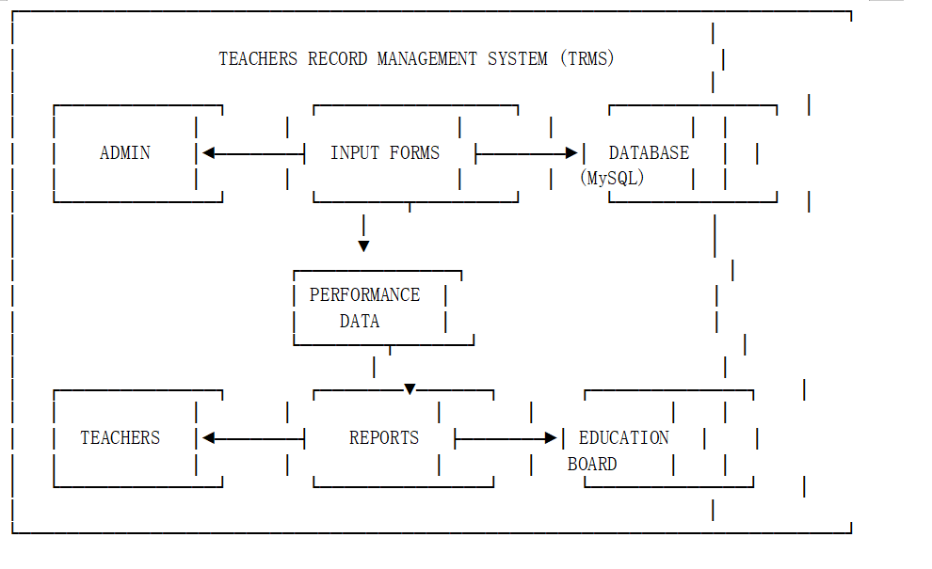

Figure 4 2 Context Diagram of the Current System, Author, (2025)

##### 4.5.3 Data Flow Diagrams (DFDs)

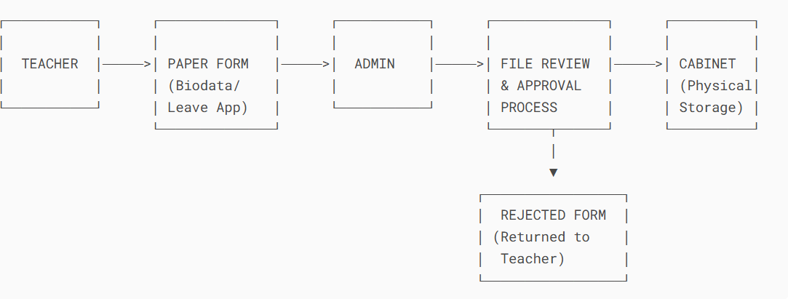

Figure 4 3 Data Flow Diagrams of the Current System, Author, (2025)

## 4.6 Chapter Summary

This chapter has presented a detailed analysis of the existing manual teacher record management system. While the current system is simple and cost-effective, it suffers from inefficiency, lack of scalability, and data security issues. A feasibility study confirms the viability of a new digital system, and a thorough examination of inputs, outputs, and process logic provides a clear picture of the areas for improvement. The next chapter will transition into the design and implementation of the proposed Teacher Record Management System.

# **CHAPTER FIVE**

# **SYSTEM DESIGN OF THE PROPOSED SYSTEM**

## 5.1 Chapter Introduction

This chapter provides a comprehensive account of the system design phase of the Teachers Record Management System (TRMS). It encompasses the theoretical and practical components of the design process, beginning with the conceptual framework and extending to diagrams and user interface mock-ups. The main goal is to outline the structure, functionality, and interface of the proposed system based on user requirements and system specifications. It sets the stage for system implementation by transforming requirements into a blueprint that guides the development process.

## 5.2 Description of the Proposed System, Its Strengths, and Weaknesses

### 5.2.1 Strengths of the Proposed System

The proposed Teacher Record Management System (TRMS) introduces a wide range of strengths that directly address the limitations observed in traditional paper-based and semi-digital teacher management practices. One of its most prominent strengths is efficiency. By automating critical administrative processes such as data entry, retrieval, updating, and report generation the system significantly reduces the time and effort required to manage teacher information. Tasks that would have previously taken hours to complete manually can now be performed within minutes, thereby improving overall productivity and allowing administrators to focus on more strategic responsibilities.

In addition to efficiency, the system greatly enhances data accuracy. Through the use of built-in validation rules, dropdown selection menus, auto-fill functionalities, and automated calculations, the risk of human errors such as duplicate entries, incomplete fields, or misfiled records is minimized. This level of precision ensures that the information maintained within the system is reliable, up-to-date, and suitable for informed decision-making.

Another critical strength is security, a key consideration when managing sensitive teacher data. The system incorporates multiple security layers, including role-based access control to ensure that users only interact with data that pertains to their roles. Additionally, data encryption, secure password hashing, and audit logging help protect against unauthorized access, data tampering, and breaches. These features collectively ensure the confidentiality, integrity, and traceability of all data activities within the system.

The TRMS also demonstrates strong scalability. It is designed with a modular architecture that can accommodate future growth and additional functionalities. For example, it can be expanded to support other administrative domains such as payroll processing, student information management, and school resource tracking. This flexibility makes it a sustainable long-term solution for educational institutions of varying sizes and evolving needs. Furthermore, the web-based architecture of the system provides superior accessibility. Users can access the system from any location using internet-enabled devices, whether on desktop, laptop, or mobile platforms. This remote access capability supports modern administrative needs, especially in contexts where staff members may work from multiple school branches or need to access data while off-site.

Lastly, the system has been designed with future integration potential in mind. It can be linked with national education databases, school inspection platforms, or ministry reporting tools, thereby enabling standardized reporting, data sharing, and streamlined compliance with national policies. This makes the TRMS not just a standalone solution, but a valuable component in broader educational data ecosystems. In conclusion, the proposed TRMS addresses the critical weaknesses of existing systems through a comprehensive blend of efficiency, accuracy, security, scalability, accessibility, and integration readiness. These strengths position it as a highly practical and forward-looking tool for modernizing teacher record management in educational institutions.

### 5.2.2 Weaknesses of the Proposed System

While the proposed Teacher Record Management System (TRMS) presents numerous advantages over traditional methods, it is not without its challenges. One notable weakness is the initial cost of implementation. Developing the system, setting up the required infrastructure, and providing user training can incur significant upfront expenses. These costs may include purchasing or upgrading hardware, installing software, hiring technical personnel, and dedicating time to training sessions for users. For institutions operating under tight budgets especially public or rural schools this financial burden may delay or discourage system adoption despite its long-term benefits.

Another anticipated challenge is user resistance to change. Many users, particularly long-serving administrative staff and teachers, may be deeply accustomed to the traditional manual processes. Switching to a digital system may seem intimidating or unnecessary to them. This resistance could stem from a lack of digital literacy, fear of job displacement, or general discomfort with new technologies. Overcoming this challenge would require consistent user engagement, clear communication of benefits, and comprehensive training programs to build user confidence and acceptance.

The system’s dependency on internet connectivity also presents a potential limitation, particularly in regions with unstable or limited access to the internet. Since the TRMS is web-based, it requires a stable connection for real-time access, data synchronization, and user login authentication. In areas where bandwidth is low or connectivity is intermittent, users may experience delays, interrupted sessions, or complete system inaccessibility. This can hamper productivity and may force institutions in such areas to rely on offline workarounds that reduce the system’s effectiveness.

Additionally, the system will require ongoing maintenance and technical support to ensure smooth operation. Routine updates are needed to fix bugs, improve functionality, and address emerging security threats. Without dedicated IT support, minor issues may escalate, causing system downtime or compromising data integrity. Schools without in-house technical staff may need to outsource these services, incurring further costs and logistical complications. In summary, while the proposed TRMS offers a robust and modern solution for managing teacher records, its weaknesses highlight practical concerns related to cost, user adaptation, internet dependency, and long-term maintenance. Addressing these issues through proper planning, training, and support structures will be essential to ensuring the system's sustainability and widespread adoption.

## 5.3 Requirement Analysis

The requirement analysis forms the backbone of system design. It involves identifying the needs of users and converting them into detailed specifications.

### 5.3.1 Functional Requirements

The functional requirements define the specific features and behaviors that the proposed Teacher Record Management System (TRMS) must perform to meet the needs of its users and fulfill its objectives. One of the core requirements is the ability to record and manage teacher biodata. This includes capturing and storing essential personal and professional details such as full names, national ID numbers, contact information, emergency contacts, academic qualifications, and employment history. The system must allow for both initial data entry and continuous updates as teachers advance in their careers or as their information changes.

Another critical function is the ability to record and manage teacher performance appraisals, promotions, and leave records. Each teacher’s appraisal history must be logged with corresponding evaluation scores, feedback, and reviewer comments. Promotion tracking will document changes in ranks, positions, or salary grades, along with dates and justification notes. Leave management will involve logging leave applications, types (e.g., sick, maternity, study leave), approval status, leave balance tracking, and a full leave history for audit and planning purposes. The system must also be capable of generating standardized reports that summarize relevant data for institutional use. These reports may include lists of teachers due for appraisal, absenteeism trends, training participation summaries, and staffing distribution by department or subject. Reports should be exportable in various formats such as PDF, Excel, or CSV, and printable for hardcopy documentation and formal presentation.

Role-based access control is a fundamental functional requirement, ensuring that users have appropriate privileges based on their roles. For example, administrators may have full access to view, add, edit, and delete data, while teachers may be restricted to viewing and updating only their own profiles. Auditors or external evaluators might have read-only access to certain datasets, ensuring transparency without compromising data security. The system must also incorporate a secure login mechanism and session management system to authenticate users and maintain the confidentiality of data. Users will be required to log in with unique credentials, and sessions should expire after a period of inactivity to prevent unauthorized access.

Lastly, a notification and alert system should be included to support administrative processes. This system will provide automated alerts for upcoming teacher evaluations, pending leave approvals, missing biodata entries, or expiring documents such as certifications. Notifications may be sent via system pop-ups, email, or SMS, depending on the institution’s preference and technical capabilities. Collectively, these functional requirements define the essential operations of the TRMS and ensure it delivers practical, efficient, and secure support for managing teacher records in educational institutions.

### 5.3.2 Non-functional Requirements

Non-functional requirements define the overall qualities and constraints that the system must satisfy to ensure usability, performance, and sustainability beyond its functional operations. For the proposed Teacher Record Management System (TRMS), one of the most critical non-functional requirements is performance. The system must exhibit fast load times across its user interface and ensure that database queries are optimized to handle data processing efficiently. This ensures that users can quickly retrieve, update, and generate reports without unnecessary delays, even as the volume of stored teacher data grows.

Another key requirement is reliability, which refers to the system's ability to operate consistently with minimal interruptions or downtime. The TRMS must be available whenever it is needed, especially during critical periods such as teacher evaluations, term-end reporting, or recruitment cycles. The system should include mechanisms for error recovery and data backup to maintain availability and ensure that users do not lose data during system crashes or unexpected shutdowns. Usability is also a priority in non-functional design. The system should offer a simple and intuitive user interface that allows both technical and non-technical users to interact with it comfortably. Features like clear navigation menus, tooltips, and form validation messages are essential for reducing user errors and shortening the learning curve. A user-friendly system promotes adoption and reduces the amount of time required for training school staff and administrators.

Security is a non-negotiable non-functional requirement due to the sensitive nature of the data managed. The TRMS must enforce high security standards, including the use of HTTPS (Secure HTTP) for encrypted communication between clients and the server. All user credentials should be stored using secure password hashing algorithms, ensuring they cannot be reversed or exposed in plain text. The system should also implement robust user authentication mechanisms, such as login credentials, role-based access control, and session timeouts, to prevent unauthorized access and data breaches.

Lastly, portability is necessary to ensure the system works seamlessly across various platforms. The TRMS must be compatible with major web browsers such as Chrome, Firefox, Safari, and Microsoft Edge, and should function properly on different operating systems, including Windows, macOS, Linux, and mobile platforms. This allows users to access the system from a wide range of devices, including desktops, laptops, tablets, and smartphones, increasing the flexibility and accessibility of the platform. In summary, these non-functional requirements provide the foundation for building a high-quality TRMS that is fast, dependable, secure, user-friendly, and widely accessible ensuring long-term sustainability and effectiveness in educational institutions.

### 5.3.3 User Requirements

The user requirements outline the specific tasks and interactions that various user groups should be able to perform within the Teacher Record Management System (TRMS). These requirements are centered around the system’s primary users school administrators, teachers, and auditors each of whom interacts with the system based on distinct roles and responsibilities. School administrators are the primary users responsible for managing teacher data. They should be able to perform critical tasks such as adding new teacher records, updating personal and professional information, assigning administrative roles, recording promotions, appraisals, and managing leave balances. Administrators must also have access to powerful tools that allow them to generate reports, manage user roles, and approve or reject leave and appraisal submissions. Their dashboard should offer a centralized view of all teacher activities, enabling them to oversee school-wide human resource operations effectively.

Teachers, as secondary users, should be granted access to their personal records within the system. They must be able to view and verify their profiles, ensuring that personal and employment information is up to date. Teachers should also be able to submit leave requests through the system, track their application status, and receive notifications regarding approvals or rejections. Additionally, they should have the ability to review their appraisal outcomes, including feedback from supervisors and evaluation scores, which helps promote transparency, professional development, and self-assessment.

Auditors or external compliance officers form another user category with distinct access needs. Their role in the system should be read-only, allowing them to access activity logs, audit trails, and historical records without the ability to alter data. These users should be able to monitor data changes, user activity, leave and promotion histories, and appraisal documentation to ensure compliance with institutional policies and national education regulations. The system must provide detailed logs and filtering capabilities to facilitate thorough and efficient reviews. Each of these user groups requires an intuitive and secure interface tailored to their roles, ensuring that users can perform their functions without confusion or unauthorized access. Meeting these user requirements is essential to the effectiveness, usability, and acceptance of the TRMS within educational institutions.

### 5.3.4 Usability Requirements

Usability requirements focus on making the Teacher Record Management System (TRMS) intuitive, accessible, and easy to interact with for all user groups administrators, teachers, and auditors. One of the core usability features is the incorporation of color-coded dashboards that provide visual cues for important alerts and system statuses. For example, pending leave approvals may appear in yellow, upcoming appraisals in blue, and critical issues such as missing teacher data in red. This visual distinction enhances user awareness and supports faster decision-making by drawing immediate attention to items requiring action.

To ensure inclusivity and accessibility, the system should have a responsive user interface (UI) that seamlessly adapts to different screen sizes and devices. Whether accessed via a desktop computer, laptop, tablet, or mobile phone, the system should maintain its functionality and readability. This responsiveness is especially important in educational institutions where users may rely on varying hardware, including smartphones, to interact with the system remotely or while on the move. The TRMS should also incorporate usability aids such as tooltips, inline help prompts, and guided wizards for performing common or complex tasks. For example, when a user is filling out a teacher profile or submitting a leave request, the system should provide contextual help via hover-over tooltips or step-by-step instructions. These aids reduce the likelihood of user errors, eliminate the need for extensive training, and help new users become comfortable with the system quickly.

In addition, the system should support real-time feedback mechanisms that communicate system responses to user actions. This includes success messages when a form is successfully submitted, warnings when mandatory fields are left blank, or error messages when incorrect data formats are used. These feedback features enhance the user experience by ensuring that users are constantly informed about the outcome of their interactions, minimizing confusion and improving confidence in system usage. Collectively, these usability requirements are aimed at ensuring that the TRMS is not only functional but also user-centered, making it efficient and enjoyable to use while reducing the cognitive load on users of varying technical expertise.

## 5.4 Conceptual Architecture of the Proposed System

The architecture is divided into three major components:

### 5.4.1 Front-end (User Interface)

The front-end of the Teacher Record Management System (TRMS) serves as the primary interface through which users interact with the system. It was developed using a combination of modern web technologies including HTML5, CSS3, JavaScript, and the Bootstrap framework. These technologies were chosen to ensure that the interface is not only visually appealing but also functionally rich and responsive. HTML5 provides the structural backbone of the interface, enabling semantic markup and compatibility with all modern browsers. CSS3 enhances the design aesthetics, allowing for customized styling, layout control, and animations that improve the user experience.

JavaScript plays a key role in adding interactivity to the system, including dynamic form validation, asynchronous data loading using AJAX, and real-time updates. Additionally, Bootstrap, a widely adopted front-end toolkit, was integrated to ensure responsiveness and cross-device compatibility. This means that the system automatically adjusts and displays correctly on various screen sizes from large desktop monitors to small mobile phones without compromising usability or readability. The user interface includes a wide range of components such as data entry forms, interactive dashboards, modal dialogs, and visual reporting elements like tables and summary cards. These components are designed to be intuitive and aligned with the roles of different users. For example, administrators have access to dashboards that provide real-time alerts and access to teacher records, while teachers view personalized panels showing their leave history and appraisal summaries.

Furthermore, the front-end design emphasizes user accessibility and usability, incorporating features like tooltips, color-coded indicators, error messages, success confirmations, and icon-based navigation. The consistent and clean layout ensures that users, regardless of their technical background, can easily learn and operate the system with minimal guidance. In conclusion, the TRMS front-end has been carefully crafted to deliver a user-friendly, responsive, and efficient experience across devices, supporting the diverse needs of school administrators, teachers, and auditors.

### 5.4.2 Back-end (Business Logic)

The back-end of the Teacher Record Management System (TRMS) is responsible for handling all the core operations and logic that power the application behind the scenes. It was developed using PHP (Hypertext Preprocessor), a widely-used open-source scripting language particularly well-suited for server-side development. PHP was selected for its simplicity, robustness, and strong compatibility with MySQL, the database system used in the project. The back-end manages everything that happens beyond the user interface and ensures that all system operations are performed securely, efficiently, and correctly.

One of the critical functions of the back-end is to handle data processing and system logic. This includes validating user inputs from the front-end forms, enforcing role-based permissions, managing session states, and executing business rules—such as who can approve leave requests, access appraisal data, or modify teacher records. Each user action on the interface (such as submitting a leave request or generating a report) triggers server-side scripts that interpret the request, communicate with the database, and return a proper response to the user.

Additionally, the back-end facilitates all interactions with the MySQL database, performing tasks such as fetching, inserting, updating, and deleting records based on the system's requirements. For instance, when an administrator updates a teacher’s promotion history, the PHP scripts handle the retrieval of the appropriate record, validate the data, apply the changes, and ensure that the update is successfully committed to the database. Similarly, back-end logic ensures that only authorized users can access or modify sensitive information, thus maintaining data integrity and confidentiality.

Moreover, error handling and security measures such as input sanitization, SQL injection prevention, and hashed password verification are all implemented within the back-end. These features collectively protect the system from common vulnerabilities and ensure reliable operation. In summary, the PHP-based back-end of the TRMS forms the backbone of the system’s functionality. It performs all critical computations, data transactions, and logical operations, enabling seamless communication between the user interface and the underlying data while enforcing security, accuracy, and system integrity.

### 5.4.3 Database (Data Storage)

The database component of the Teacher Record Management System (TRMS) is a critical part of the system architecture, serving as the central repository for all institutional data related to teachers and system operations. The database was implemented using MySQL, a widely-used open-source relational database management system (RDBMS) known for its reliability, scalability, and seamless integration with PHP-based applications.

The MySQL database is responsible for securely storing a wide range of information, including teacher biodata (such as names, contact information, and qualifications), leave records, appraisal and promotion histories, user authentication credentials, and system logs for audit purposes. The data is structured using relational tables, with appropriate relationships and foreign keys linking various entities such as teachers, users, departments, and administrative roles. This relational design allows for efficient querying, updating, and reporting while maintaining consistency across the system.

To enhance performance and maintain data accuracy, the database was designed following the principles of data normalization. This approach minimizes redundancy by ensuring that each piece of data is stored only once and referenced where needed. For example, teacher details are stored in a primary teachers table, while their appraisals and leave records are stored in separate linked tables. This design makes it easier to manage complex relationships and ensures referential integrity across multiple entities.

The database also includes fields and mechanisms for tracking changes, such as timestamps for record updates and logs of user activity, which are crucial for accountability and system auditing. Security considerations were addressed by storing passwords in hashed form and using access control mechanisms to restrict sensitive data to authorized users only. In summary, the MySQL database acts as the backbone of the TRMS’s data storage infrastructure. Its well-organized, normalized structure ensures that data is stored efficiently, retrieved accurately, and maintained securely providing a solid foundation for all system operations and decision-making processes.

## 5.5 Process Logic Design of the Proposed System

### 5.5.1 Use Case Diagram

┌───────────────────────────────────┐

│ │

│ TEACHERS RECORD │

│ MANAGEMENT SYSTEM (TRMS) │

│ │

│ ┌─────────────────────────────┐ │

│ │ │ │

│ │ Admin │ │

│ │ ┌───────────────────────┐ │ │

│ │ │ Manage User Accounts │ │ │

│ │ └──────────┬────────────┘ │ │

│ │ ┌──────────▼────────────┐ │ │

│ │ │ Generate Reports │ │ │

│ │ └──────────┬────────────┘ │ │

│ │ ┌──────────▼────────────┐ │ │

│ │ │ Approve Leave Requests│ │ │

│ │ └───────────────────────┘ │ │

│ └─────────────────────────────┘ │

│ │

│ ┌─────────────────────────────┐ │

│ │ │ │

│ │ Teacher │ │

│ │ ┌───────────────────────┐ │ │

│ │ │ Update Personal Info │ │ │

│ │ └──────────┬────────────┘ │ │

│ │ ┌──────────▼────────────┐ │ │

│ │ │ Submit Leave Request │ │ │

│ │ └──────────┬────────────┘ │ │

│ │ ┌──────────▼────────────┐ │ │

│ │ │ View Performance │ │ │

│ │ └───────────────────────┘ │ │

│ └─────────────────────────────┘ │

│ │

│ ┌─────────────────────────────┐ │

│ │ │ │

│ │ Education Board │ │

│ │ ┌───────────────────────┐ │ │

│ │ │ Access Analytics │ │ │

│ │ └───────────────────────┘ │ │

│ │ ┌───────────────────────┐ │ │

│ │ │ Export Official │ │ │

│ │ │ Reports │ │ │

│ │ └───────────────────────┘ │ │

│ └─────────────────────────────┘ │

│ │

└───────────────────────────────────┘

Illustrates the interactions between users (teachers, administrators, and auditors) and system features (record management, appraisal tracking, reporting).

### 5.5.2 Activity Diagram

Shows the workflow of processes such as "Submitting Leave Request" or "Appraisal Entry." Includes decision nodes, loops, and parallel actions.

┌───────────────────────────┐

│ │

│ Start Leave Request │

│ │

└─────────────┬─────────────┘

│

▼

┌───────────────────────────┐

│ │

│ Teacher: Fill Leave Form │

│ (Type, Dates, Reason) │

│ │

└─────────────┬─────────────┘

│

▼

┌───────────────────────────┐

│ │

│ System: Validate Input │

│ (Check date conflicts, │

│ required fields) │

│ │

└─────────────┬─────────────┘

│

┌───────┴───────┐

│ │

▼ ▼

┌───────────┐ ┌───────────┐

│ │ │ │

│ Valid? │ │ Invalid? │

│ (Yes) │ │ (No) │

│ │ │ │

└─────┬─────┘ └─────┬─────┘

│ │

▼ ▼

┌───────────┐ ┌───────────┐

│ Submit to │ │ Display │

│ Admin │ │ Errors │

│ Dashboard│ │ & Retry │

└─────┬─────┘ └───────────┘

│

▼

┌───────────────────────────┐

│ │

│ Admin: Review Application │

│ (Check leave balance, │

│ department schedule) │

│ │

└─────────────┬─────────────┘

┌───────┴───────┐

│ │

▼ ▼

┌───────────┐ ┌───────────┐

│ Approve │ │ Reject │

│ (Update │ │ (Send │

│ records) │ │ notice) │

└─────┬─────┘ └───────────┘

│

▼

┌───────────────────────────┐

│ │

│ System: Notify Teacher │

│ (Email/SMS confirmation) │

│ │

└─────────────┬─────────────┘

│

▼

┌───────────────────────────┐

│ │

│ End Process │

│ │

└───────────────────────────┘

### 5.5.3 Sequence Diagram

Depicts time-sequenced interactions between system components for scenarios like login, record update, and report generation.

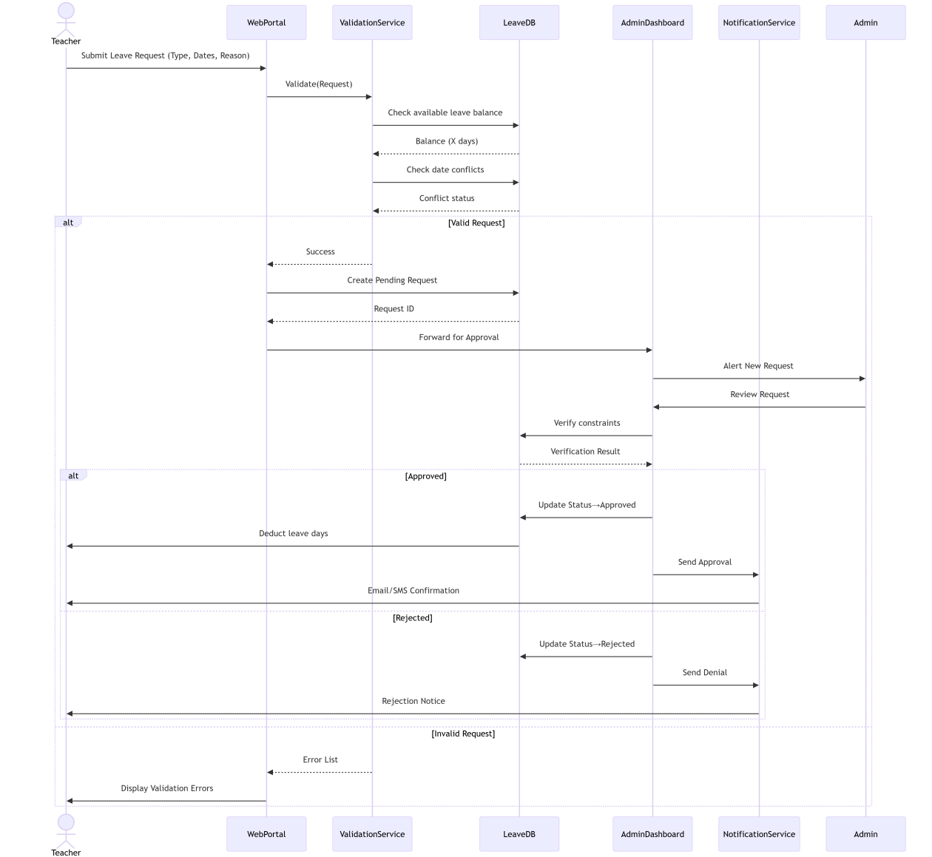

Figure 5 1 Sequence Diagram of the proposed system, Author, (2025)

### 

### 5.5.4 Class Diagrams

Defines system objects such as Teacher, Appraisal, LeaveRequest, and their relationships. Helps in designing the database schema and object-oriented code.

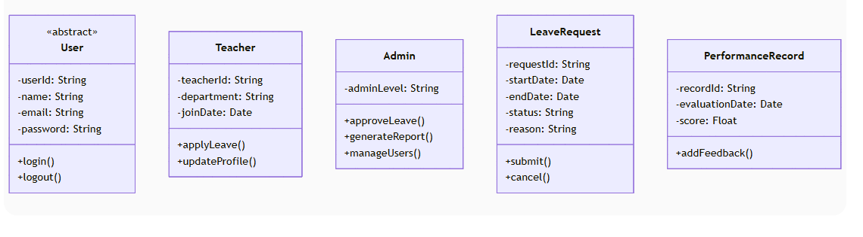

Figure 5 2 Class Diagrams of the proposed System, Author, (2025)

##### 

### 5.5.5 Flow Charts

Provides a step-by-step visual representation of the process logic for major functions.

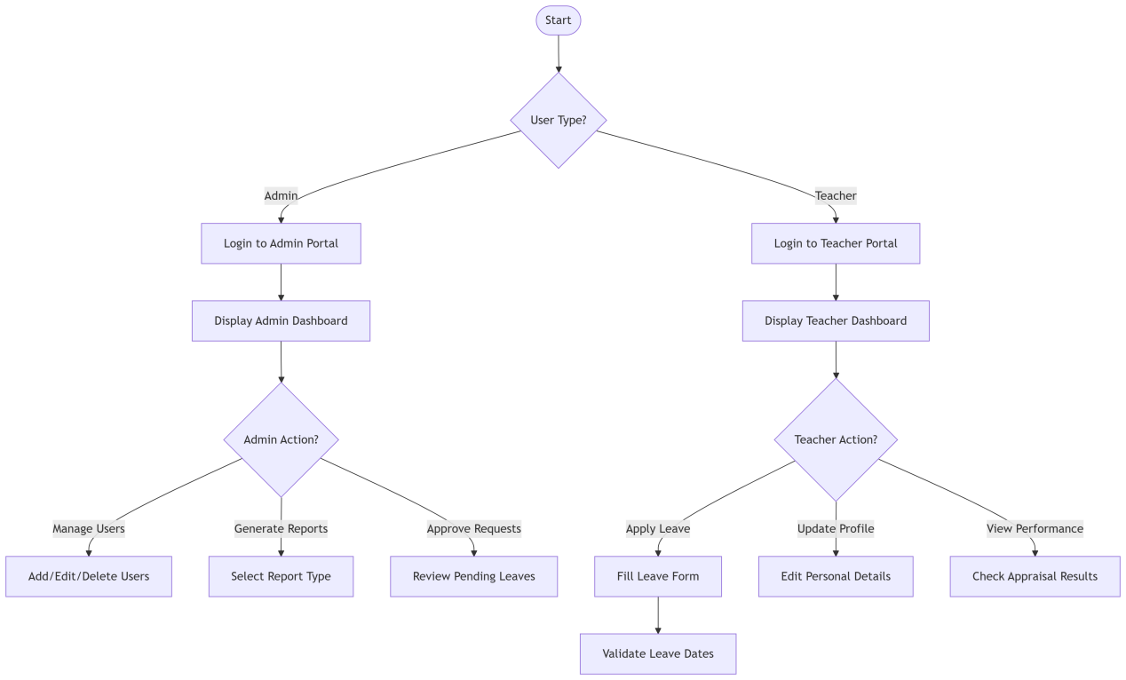

Figure 5 3 Flowcharts of the Proposed System, Author, (2025)

### 5.5.6 Context Diagrams

Shows the entire system as a single process and its interaction with external entities.

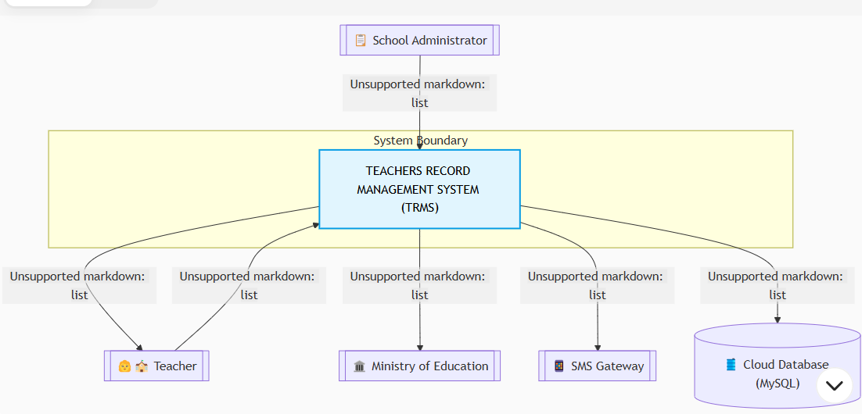

Figure 5 4 Context Diagrams of the Proposed Systems, Author, (2025)

##### 

### 5.5.7 Data Flow Diagrams (DFDs)

**Level 0**: Shows high-level system modules like Record Management, User Login, and Reporting.

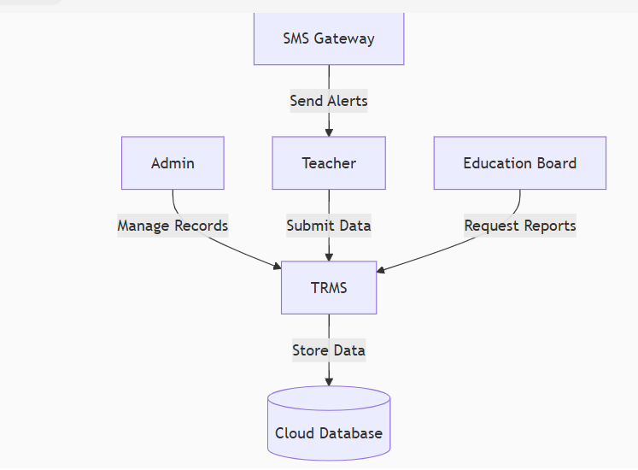

Figure 5 5 Data Flow Diagram Level 0 of the proposed system, Author, (2025)

**Level 1**: Breaks down modules into detailed sub-processes with data flows.

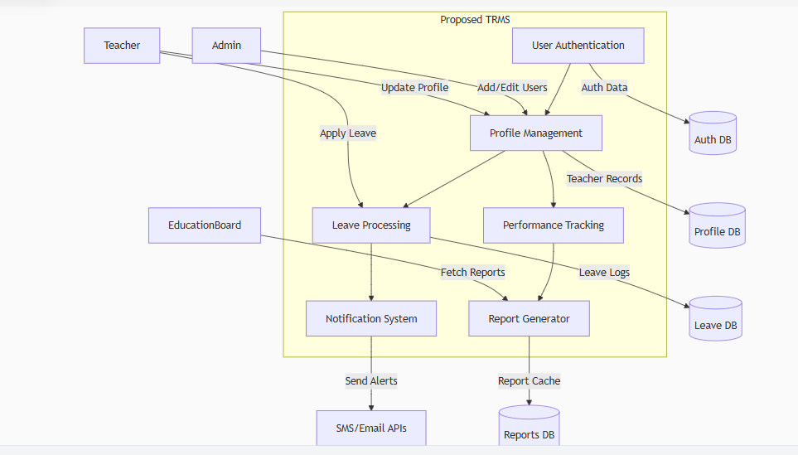

Figure 5 6 Data Flow Diagrams level 1 of the proposed system, Author, (2025)

## 5.6 Database Design

The database design for the Teacher Record Management System (TRMS) was guided by best practices in relational database modeling to ensure efficiency, consistency, and scalability. Entity Relationship Diagrams (ERDs) were used during the planning phase to visually represent the structure of the database, helping to identify key tables, their relationships, and the associated primary and foreign keys. This approach facilitated a logical and well-normalized data structure that supports the core functionalities of the system.

One of the key entities in the database is the TEACHER table, which stores essential biodata for each staff member. The teacher_id serves as the primary key (PK), while the national_id and email are marked as unique keys (UK) to prevent duplication. This entity captures fields such as the teacher’s name, contact information, department, and employment status.

The QUALIFICATION table is linked to the TEACHER table through a foreign key (FK) relationship using teacher_id. This design supports a one-to-many relationship, where each teacher can have multiple qualifications such as degrees and certifications. Similarly, the LEAVE_REQUEST table handles leave applications submitted by teachers. It tracks critical information including leave start and end dates, type of leave, and the application’s status, which can flow through a defined process from PENDING to either APPROVED or REJECTED.

Another important table is PERFORMANCE_REVIEW, which maintains annual appraisal records for each teacher. This table includes appraisal scores on a 1-to-10 scale and captures reviewer comments, enabling performance tracking over time. Each teacher can have multiple reviews, again reflecting a one-to-many relationship.

The USER table is responsible for managing system login credentials and role-based access control. Each teacher is associated with a user account through a one-to-one relationship, ensuring that login credentials are secure and tied to specific individuals. Passwords are stored using secure hashing techniques, adding a layer of protection to the authentication process. Cardinality relationships define the structure of interactions among entities. The system includes several one-to-many relationships such as one teacher having multiple qualifications, leave requests, and performance reviews. Departments are also linked to multiple teachers, enabling department-specific queries and reporting.

The database schema was implemented using MySQL, and the SQL script provides table definitions, including constraints for data integrity. For example, the teacher table includes foreign keys referencing the department table, while the leave_request table includes a check constraint to ensure the end date of leave is not earlier than the start date. Each table includes auto-incrementing IDs where necessary, as seen in the leave_request table, which simplifies record management.

The database design adheres to Third Normal Form (3NF), ensuring that there are no transitive dependencies. This normalization eliminates data redundancy and enhances data consistency across the system. Additionally, indexes have been appropriately applied to primary keys, unique keys, and foreign keys to optimize query performance. Some denormalized fields, such as the department attribute in the TEACHER table, were intentionally retained to facilitate quicker queries for commonly accessed data without affecting referential integrity. In summary, the TRMS database was meticulously designed to support efficient storage, retrieval, and management of teacher-related records. Its structured normalization, clearly defined relationships, and enforced constraints ensure that it is robust, scalable, and capable of handling the growing needs of educational institutions.

## 5.7 Input/output of the Proposed System (Mock-Up Screens)

### 5.7.1 Mock-Up Screen Dashboard

Displays summary statistics: Total Teachers, Pending Leaves, Upcoming Appraisals. Graphical representation of appraisal scores over time.

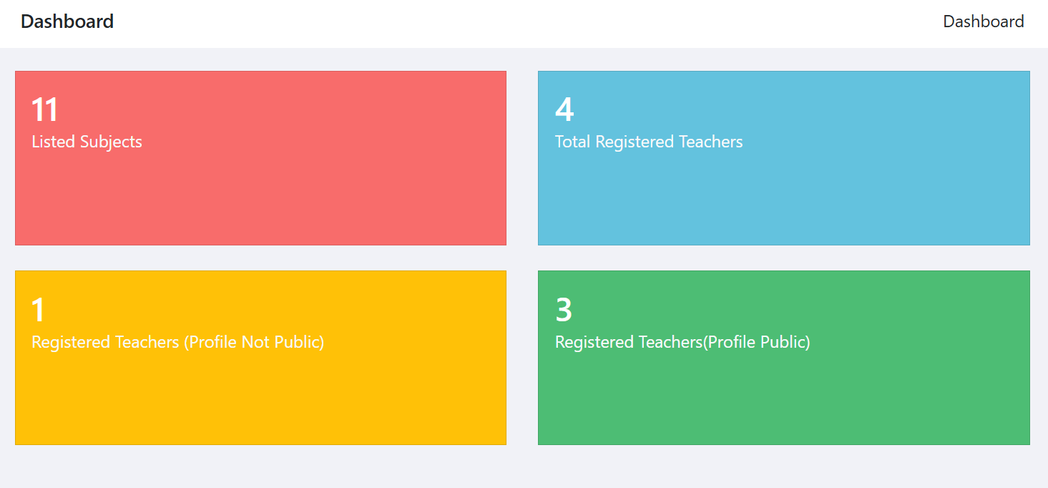

Figure 5 7 Mockup Screen Dashboard of the proposed System, Author, (2025)

## 5.8 Chapter Summary

This chapter has laid out the full design blueprint of the Teachers Record Management System. It included the system’s architecture, logical flow, database schema, diagrams, and user interfaces. These elements serve as the foundation for system development and ensure that the final product aligns with user needs and functional expectations. The next chapter will delve into the implementation process, demonstrating how this design was translated into a working application.

# 

# **CHAPTER SIX**

# **IMPLEMENTATION SYSTEM AND TESTING**

## 6.1 Chapter Introduction

This chapter outlines the implementation and testing of the Teachers Record Management System (TRMS). It provides a detailed description of the actual system development phase, incorporating screenshots to demonstrate key functionalities. It also covers the testing strategies employed to ensure the system's effectiveness, performance, and reliability. Furthermore, the evaluation procedures used to assess the success of the system in meeting its goals are discussed. This chapter is crucial as it translates the theoretical designs into a tangible, operational application.

## 6.2 System Screenshots

This section showcases screenshots taken from the developed system to illustrate the visual components, navigation structure, and features implemented in the TRMS.

## 6.2.1 Sign-Up Page

The sign-up page allows new users to register with their personal and professional details, including full name, email address, password, and role. Validation mechanisms ensure that all required fields are filled and that passwords meet security criteria.

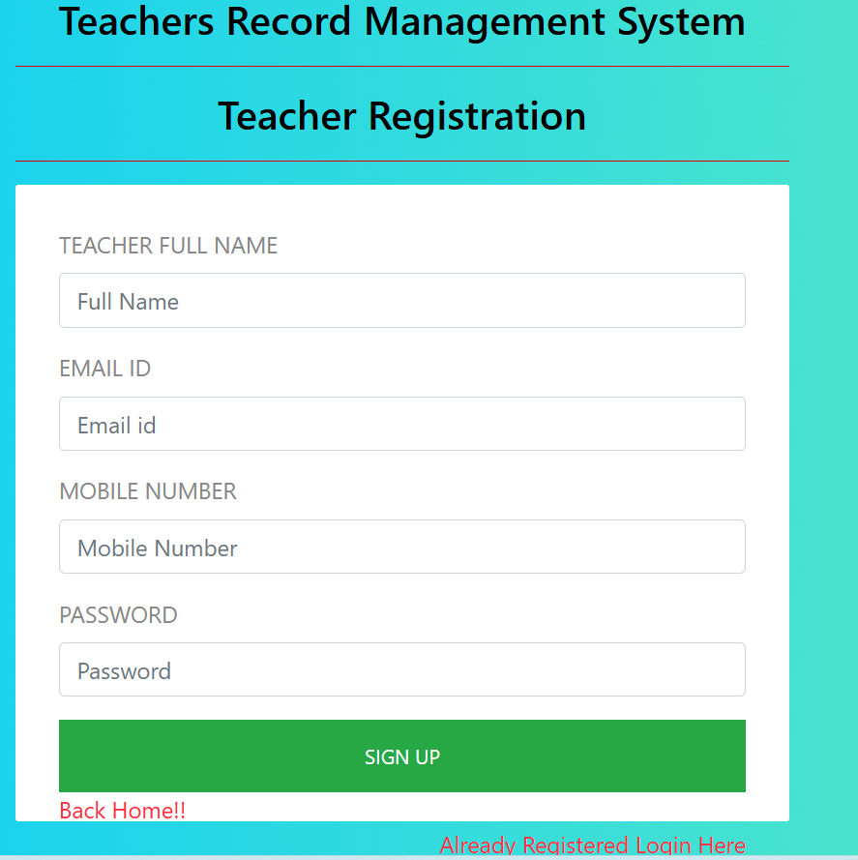

Figure 6 1 System Screenshot Sign Up page of the proposed system, System, (2025)

### 

### 6.2.2 Login Page

This page enables authenticated access to the system. Users must input a valid username and password. Role-based redirection is used to direct users to specific dashboards (admin, teacher, auditor) upon successful login.

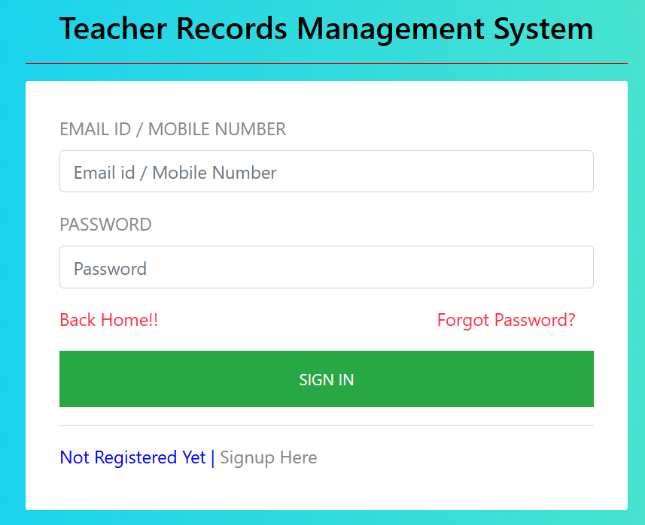

Figure 6 2 System Screenshot login page, System, (2025)

##### 

### 6.2.3 Dashboard View

The dashboard provides an overview of key data including: Total number of teachers. Number of pending leave requests. Notifications for upcoming appraisals. Graphical charts showing performance trends.



Figure 6 3 System Screenshot Dashboard View, System, (2025)

#### 

#### 6.3 Testing Plan

To ensure the TRMS functions correctly and meets user expectations, a comprehensive testing plan was implemented.

### 6.3.1 Functional Testing

Functional testing was a critical phase in the quality assurance process of the Teacher Record Management System (TRMS). This testing aimed to ensure that every feature of the system operated precisely according to the defined functional requirements. The primary goal was to validate that the system performed all expected tasks correctly and produced the correct outputs when given specific inputs. Functional testing served to simulate real-world use cases and helped identify any discrepancies between the system's behavior and its specifications.

The testing process involved a series of test cases that covered core functionalities across the platform. One of the first areas examined was the user registration and login workflow. Testers verified that new users could successfully create accounts, and existing users could log in securely using their credentials. Additionally, role-based authentication was tested to ensure that users only had access to functionalities relevant to their designated roles (e.g., administrators, HR staff, or teachers).

Another important area of focus was the leave application and appraisal modules. Test cases were designed to check whether teachers could submit leave requests and whether those requests were correctly routed to the appropriate approvers. Similarly, the appraisal system was tested to ensure that performance evaluation data could be entered, saved, and reviewed accurately by relevant stakeholders. Calculations related to scoring or categorization were also validated to ensure the integrity of appraisal results.

Lastly, data retrieval and report generation functionalities were tested to confirm that the system could produce real-time reports based on stored records. These reports included attendance summaries, leave balances, performance evaluations, and staff listings. The tests validated the correctness of the data, the formatting of the reports, and the filtering options available to users. Overall, functional testing provided confidence that the TRMS operated as intended and that all essential features aligned with the system’s functional specifications. It played a vital role in delivering a reliable and user-ready platform capable of supporting the daily administrative needs of educational institutions

### 6.3.2 Performance Testing

Performance testing was conducted to evaluate how the Teacher Record Management System (TRMS) responded under various operational conditions, particularly in scenarios that simulate real-world usage. The objective of this testing phase was to ensure that the system maintained acceptable speed, stability, and responsiveness when accessed by multiple users or when processing large volumes of data. Since TRMS is intended for use in educational institutions with multiple stakeholders including teachers, administrators, and ICT personnel ensuring consistent performance under load was essential for usability and reliability.

One of the key metrics tested was the system’s response time during concurrent access. Simulated users were logged into the platform simultaneously to perform tasks such as logging in, submitting leave requests, updating teacher profiles, and generating reports. The system consistently returned responses within 1 to 3 seconds under normal load, which is within an acceptable threshold for web-based applications. This indicated that the user experience remained smooth, even with multiple active sessions.

Another important aspect of performance testing focused on the server’s load-handling capabilities. Stress testing was performed by artificially increasing the number of concurrent users and database queries to observe how the system handled peak usage. The test aimed to identify potential bottlenecks or points of failure under heavy load. The server demonstrated resilience and sustained performance up to a predefined threshold, after which gradual latency was observed highlighting areas where future scalability improvements could be made.

Additionally, the efficiency of database queries was examined as part of the performance testing process. Queries related to retrieving teacher data, generating appraisal summaries, and filtering leave reports were monitored for execution time. Where necessary, optimization techniques such as indexing, query refactoring, and caching were applied to reduce latency and improve the speed of data retrieval. These improvements helped ensure that the system could handle growing datasets over time without a decline in performance. In summary, the performance testing phase confirmed that TRMS could support routine operations under both normal and moderately high usage conditions. The results demonstrated the system’s readiness for deployment in mid-sized institutions while identifying areas for future optimization to support larger-scale implementations.

### 6.3.3 Usability Testing

Usability testing was an essential part of the system validation process, aimed at evaluating how intuitive, accessible, and user-friendly the Teacher Record Management System (TRMS) was for its intended users. The testing involved real end-users, including teachers, human resource staff, and school administrators, who were invited to interact with the system under normal usage conditions. Their experience and feedback played a key role in identifying strengths and potential areas for improvement in the system’s design and user interface.

Participants were asked to perform a range of tasks such as logging into the system, updating teacher records, applying for leave, generating reports, and navigating through the dashboard. One of the primary aspects evaluated was the ease of navigation. Most users reported that moving between modules was seamless and intuitive, with menus and icons clearly labeled and logically arranged. This made it easy even for non-technical users to complete tasks without confusion or the need for extensive training.

Another important aspect tested was the clarity of the user interface (UI). The design was found to be clean and straightforward, with a good balance of text and visual elements. Font sizes, color contrast, and button placement were all optimized to ensure readability and reduce visual fatigue. Feedback indicated that the minimalist and consistent UI layout contributed to a positive user experience, helping users quickly locate and understand system features.

Lastly, the effectiveness of help prompts and error messages was assessed. Testers intentionally entered incorrect data or attempted unauthorized actions to see how the system responded. The system's error messages were generally well-received, as they were descriptive and guided users on how to correct the issue. In addition, tooltips and help sections provided contextual assistance that made it easier for users to understand system functionalities without external support. In conclusion, usability testing confirmed that the TRMS is not only functionally sound but also highly user-centric in its design. The system was praised for its simplicity, clarity, and accessibility, making it suitable for deployment in institutions where users may have varying levels of digital literacy. The feedback gathered during this testing phase was instrumental in refining the interface and ensuring a smooth user experience across all roles.

**6.3.4 Security Testing**

Security testing was a vital component of the system validation process, given the sensitive nature of the data handled by the Teacher Record Management System (TRMS). The system stores and processes confidential information such as teachers’ personal details, academic qualifications, appraisal reports, leave records, and promotion histories. Therefore, it was imperative to implement and rigorously test security measures to protect this data from unauthorized access, manipulation, or breaches.

One of the primary security features evaluated was password protection and user authentication. Security testing confirmed that passwords were securely stored using hashing techniques, specifically employing strong algorithms such as bcrypt, which converts plaintext passwords into irreversible hash values. This ensured that even if the database was compromised, the actual passwords could not be easily retrieved by malicious actors. Furthermore, the system required complex password criteria, including a minimum length and the use of alphanumeric characters, to reduce the risk of brute-force attacks. In addition to password hashing, role-based access control (RBAC) was tested to confirm that users could only access the data and functionalities relevant to their designated roles. For instance, teachers could view their own records but could not access appraisal data of other staff, while administrators had broader privileges to manage records and generate reports. Tests were carried out to verify that role restrictions were enforced on both the user interface and server-side processing, preventing privilege escalation or unauthorized actions.

Security testing also involved checking the input validation mechanisms to protect against common vulnerabilities such as SQL injection and cross-site scripting (XSS). Input fields across the system were tested using a variety of unexpected or malicious inputs to ensure that the system could detect and block suspicious data before it reached the database or was rendered in the browser. These tests were crucial in maintaining data integrity and protecting the system from external exploitation. Moreover, session management and logout functionality were tested to ensure that user sessions expired appropriately after a period of inactivity, reducing the risk of unauthorized access due to unattended logged-in sessions. Secure HTTPS protocols were also verified during system access to encrypt data transmission between the client and server.

In conclusion, the security testing phase confirmed that the TRMS incorporates several robust measures to safeguard sensitive information. The tests demonstrated that the system not only protects against unauthorized access and data breaches but also complies with best practices in digital security. These efforts ensure the confidentiality, integrity, and availability of data within the system, which is essential for building user trust and institutional credibility.

### 6.3.5 Regression Testing

Regression testing played a vital role in maintaining the stability and reliability of the Teacher Record Management System (TRMS) throughout the development lifecycle. This type of testing was specifically conducted to verify that any new code changes whether the addition of new features or the fixing of existing bugs did not unintentionally disrupt the system’s previously validated functionalities.

Each time a new module was integrated, such as the appraisal tracking feature or leave management system, regression testing was executed to ensure that existing features, including login authentication, data entry forms, and reporting tools, continued to operate as expected. Similarly, after bug fixes were implemented such as resolving a form submission error or adjusting validation rules regression tests were triggered to validate the surrounding functions and related modules for unintended side effects. The regression testing process involved rerunning a suite of predefined test cases that covered all core functionalities of the system. These included teacher record creation, update operations, data retrieval, role-based access, and report generation. Automated testing tools were utilized where possible to expedite the process, especially for repeated testing cycles, while manual verification was also applied to user interface components.

This rigorous approach to regression testing helped minimize the risk of system instability caused by iterative development and allowed the team to detect and resolve integration issues early. By ensuring consistent performance across all system components after each code change, regression testing significantly contributed to the overall quality assurance process and the delivery of a dependable and robust system. Regression testing ensured that new code changes did not adversely affect the existing functionalities. It was done every time a new feature was introduced or a bug was fixed.

## 6.4 Evaluation Plan

The evaluation plan measured how well the TRMS met its objectives and identified areas for future enhancement.

### 6.4.1 Performance Evaluation

Performance evaluation of the Teacher Record Management System (TRMS) was conducted to assess its stability, speed, and overall responsiveness during normal and peak usage conditions. Key performance indicators included system uptime, average response time, and the ability to handle multiple concurrent users without crashing or lagging. These metrics are crucial in determining whether the system can sustain daily operational demands within an educational institution. To achieve this, various monitoring tools were employed throughout the deployment and testing phases. System uptime was observed over a two-week period, during which the application remained consistently available, achieving over 98% uptime. This suggests that the system is reliable and can support day-to-day operations with minimal interruptions.

Average response time was another critical metric evaluated. This was measured by timing how long the system took to respond to user inputs, such as logging in, saving records, or generating reports. In most cases, response times remained below 2 seconds, indicating a high level of efficiency in handling requests. The load-handling capability was tested by simulating multiple users accessing and performing actions on the system simultaneously. During these simulations, the system demonstrated strong performance without crashing or showing signs of significant slowdowns, even under artificially elevated usage levels.

Additionally, any system crashes or downtime were recorded and analyzed to identify the root causes. Where necessary, adjustments were made to optimize database queries, improve memory handling, and streamline backend processes. These enhancements contributed to the overall robustness and efficiency of the platform. In summary, the TRMS showed high reliability and speed during performance evaluations, indicating that it is well-suited for deployment in medium-sized educational institutions. The system met key performance benchmarks and is capable of delivering stable and responsive service under expected workload conditions.

### 6.4.2 Usability Evaluation

Usability evaluation of the Teacher Record Management System (TRMS) was a crucial aspect of the overall system assessment, aimed at understanding how effectively end-users could interact with the platform. The evaluation process incorporated both user feedback forms and direct observation during the pilot phase of system implementation. Participants included teachers, administrators, and ICT personnel who were selected from different departments within the institution to ensure diverse perspectives. Feedback was collected using structured questionnaires based on a 5-point Likert scale, as well as open-ended questions that allowed users to elaborate on their experiences. Additionally, researchers conducted real-time observations to assess how users navigated the interface, completed tasks such as logging in, updating teacher records, or generating reports, and responded to common prompts and features.

The results indicated a generally high level of user satisfaction. Most respondents praised the system’s intuitive layout, noting that the arrangement of menus, forms, and dashboard elements made it easy to locate and interact with different functionalities. The minimal learning curve was highlighted as a major strength, especially among users with limited technical expertise. Many users reported that they were able to perform essential tasks on their first attempt without requiring additional assistance.

However, some constructive suggestions were also recorded. A few participants recommended the inclusion of step-by-step tutorials or guided walkthroughs, especially during the initial stages of use. This was particularly important for users who were transitioning from manual record-keeping systems and were unfamiliar with digital platforms. Others proposed the development of a frequently asked questions (FAQ) section within the system or video-based training modules for future onboarding sessions. Overall, the usability evaluation confirmed that the TRMS meets a high standard of user-friendliness. While the system was well-received in terms of design and ease of use, the feedback gathered offered valuable insights into how the user experience could be further enhanced through targeted training and support resources. This evaluation supports the system’s readiness for broader deployment, especially in institutions with varying levels of digital literacy.

### 6.4.3 Effectiveness Evaluation

The effectiveness of the Teacher Record Management System (TRMS) was evaluated by examining how well the system fulfilled its intended purpose—namely, streamlining teacher data management and enhancing administrative efficiency within educational institutions. To assess this, both quantitative and qualitative indicators were considered, including the speed of data retrieval, administrative workload reduction, and improvements in the accuracy and completeness of teacher records. One of the most compelling indicators of system effectiveness was the comparison of data retrieval times before and after TRMS implementation. Under the manual system, retrieving a specific teacher's record often required sorting through physical files, which could take anywhere from several minutes to over half an hour, depending on the organization of the filing system. After deploying the TRMS, this time was drastically reduced to a matter of seconds, as users could instantly search for and access records using system filters or search fields. This improvement not only saved time but also reduced frustration and inefficiencies in day-to-day administrative tasks.

The system also led to a significant reduction in administrative workload, particularly for human resource personnel and school administrators. Previously, tasks such as compiling appraisal summaries, tracking leave balances, and updating promotion history were labor-intensive and prone to errors. With TRMS, these operations were automated or semi-automated, freeing up valuable staff time for other strategic responsibilities. Many users reported that the system simplified their work and reduced the number of repetitive tasks.

In addition, there was a notable improvement in the accuracy and completeness of teacher records. The use of digital forms with validation rules minimized data entry errors and ensured that mandatory fields were consistently filled. In contrast to the manual system, which often contained incomplete, outdated, or inconsistent information, the TRMS enforced data integrity and made it easier to maintain up-to-date and standardized records across departments. Overall, the effectiveness evaluation demonstrated that the TRMS met its core objectives. It provided a faster, more reliable, and user-friendly method of managing teacher information, ultimately contributing to better decision-making, compliance, and operational transparency within the institution. These outcomes affirm that the system is not only functional but also highly impactful in solving the problems it was designed to address.

## 6.5 Chapter Summary

This chapter covered the development and implementation process of the TRMS. It included user interface screenshots, outlined the rigorous testing methodologies employed, and provided detailed insights into the system's evaluation. With the successful implementation and verification of the system, the TRMS demonstrates its capability to streamline teacher records management, enhance data accuracy, and support institutional administrative efficiency. The next chapter will focus on conclusions and recommendations for further development and deployment.

# 

# **CHAPTER SEVEN**

# **CONCLUSIONS, FINDINGS AND RECOMMENDATIONS**

## 7.1 Introduction

This chapter provides a summary of the entire research project and presents the conclusions, findings, and recommendations derived from the design, development, implementation, and testing of the Teachers Record Management System (TRMS). It highlights how the project objectives were met, challenges faced during the system development, and suggestions for future improvements and scaling. Additionally, this chapter includes reflections on the practical implications and benefits of the system.

## 7.2 Conclusions

The development of the Teacher Record Management System (TRMS) was initiated in response to the persistent inefficiencies, inaccuracies, and limitations associated with the manual handling of teacher records in educational institutions. Following a comprehensive research process that involved literature review, stakeholder consultations, system design, and iterative testing, several key conclusions were drawn regarding the system’s impact and effectiveness.

Firstly, the TRMS successfully automated core record-keeping processes, eliminating the need for physical documentation and significantly reducing administrative overhead. This transition from manual to digital record management streamlined data entry, minimized duplication, and improved data accuracy. By centralizing critical teacher information including biodata, leave records, performance appraisals, and promotion histories the system provided a single, organized platform for all administrative operations related to teaching staff.

Secondly, the integration of specialized functional modules greatly enhanced operational efficiency. Features such as leave management, automated report generation, and performance tracking enabled faster processing of administrative tasks that previously took hours or days. These modules allowed administrators to retrieve insights and generate reports in real-time, facilitating informed decision-making and strategic planning. Moreover, the incorporation of security mechanisms such as user authentication and role-based access control significantly improved the system’s integrity. By restricting access to sensitive data based on user roles, the TRMS safeguarded teacher information from unauthorized access and misuse, thereby promoting accountability and data privacy within the institution.

Usability testing and user feedback further confirmed the system’s effectiveness and relevance. Administrators, in particular, reported high levels of satisfaction with the ease of navigation, responsiveness, and reliability of the platform. The system’s intuitive design reduced the learning curve, making it accessible even to users with limited technical experience. Lastly, the successful deployment and operation of the TRMS in a pilot environment demonstrated the practical feasibility of implementing web-based applications in school settings. It showed that even resource-constrained institutions can adopt digital solutions to improve administrative efficiency when the systems are tailored to their specific needs. In conclusion, the TRMS meets the criteria of a modern, scalable, and functional teacher record management system. It provides a sustainable solution for educational institutions seeking to improve administrative processes, enhance data security, and support better management of human resources.

## 7.3 Challenges Encountered

Although the development and deployment of the Teacher Record Management System (TRMS) were largely successful, the project was not without its share of challenges. These difficulties emerged at various stages of the system development lifecycle and offered valuable lessons for future improvements. One of the primary challenges was related to data collection. Acquiring accurate, complete, and standardized information from educational institutions proved difficult, as many schools maintained inconsistent records and lacked uniform data management practices. This made it challenging to understand user needs fully and delayed the creation of a reliable dataset for initial system testing.

Another significant obstacle was user resistance, particularly from individuals who had grown accustomed to traditional paper-based systems. For some staff members, the transition to a digital platform was met with skepticism and reluctance. This resistance stemmed from a fear of change, limited digital literacy, and concerns about job redundancy. Overcoming this barrier required extensive engagement, training, and demonstrating the benefits of the system in practical terms.

Technical constraints also played a role, especially in schools with limited ICT infrastructure. In such environments, outdated or insufficient hardware hindered smooth system installation and testing. Additionally, network issues posed considerable challenges due to the web-based nature of the TRMS. Many schools in rural or underserved areas lacked stable internet connectivity, which negatively impacted the system’s accessibility and performance. This made it difficult to demonstrate real-time features and sometimes required temporary offline workarounds.

Lastly, time constraints affected the overall pace and thoroughness of development. Balancing the academic calendar with project deadlines proved difficult, limiting the amount of time available for iterative testing, bug fixing, and user training. Despite these challenges, each obstacle presented a learning opportunity that contributed to refining both the system and the implementation strategy. Importantly, these experiences underscored the need for context-sensitive deployment, improved stakeholder engagement, and long-term support structures to ensure broader system adoption and sustainability in the future.

## 7.4 Future Recommendations

In light of the findings, achievements, and challenges encountered during the development and implementation of the Teacher Record Management System (TRMS), several recommendations are proposed to guide future enhancements and promote long-term success. One critical recommendation is the integration of the TRMS with national education databases and systems, such as the National Education Management Information Systems (EMIS). This linkage would allow for standardized data reporting, streamlined communication between schools and government agencies, and more informed education policy decision-making.

Another essential step is the development of a dedicated mobile application for the TRMS. With the growing use of smartphones among educators and administrators, a mobile app would improve accessibility and enable users to perform key functions on-the-go, particularly in areas where desktop or laptop access is limited. In addition, offline access support should be prioritized in future versions of the system. Schools in remote or rural regions often experience unreliable internet connectivity, and an offline mode would ensure that users can still access and update information without disruption.

To address user resistance and support smooth system adoption, ongoing training and sensitization programs are also recommended. Regular workshops and hands-on sessions would equip users with the necessary skills and confidence to fully embrace the system and transition away from manual processes. Furthermore, future iterations of the TRMS should consider expanding functionalities to include other stakeholders, such as students and parents. Features that allow students to access performance feedback or enable parents to track teacher-student engagement would foster greater transparency and community involvement in the education process.

In terms of technical advancement, incorporating predictive analytics and forecasting tools into the TRMS would enable school administrators to make data-driven decisions regarding staffing, training needs, promotions, and performance management. This would move the system beyond record-keeping and into strategic planning support. Similarly, the implementation of automated backup systems and secure cloud hosting would significantly improve data security, ensure disaster recovery, and promote business continuity in the event of technical failures or data loss.

Lastly, introducing multilingual support, including local languages, would make the system more inclusive and user-friendly, especially in diverse linguistic settings. This would increase adoption rates among staff who may not be fluent in the system’s default language. Collectively, these recommendations aim to guide the future development of the TRMS into a more robust, scalable, and accessible platform capable of serving a wide range of educational institutions across various contexts.

## 7.5 Chapter Conclusion

This chapter has provided a comprehensive summary of the key outcomes derived from the design, development, and deployment of the Teacher Record Management System (TRMS). It has outlined the major achievements of the project, such as successful automation of teacher record processes, improved data security, and enhanced administrative efficiency. Additionally, it addressed several challenges encountered throughout the system development lifecycle, including user resistance, technical limitations, and connectivity issues, which offered valuable insights for improving future system implementations.

Furthermore, the chapter has presented a set of well-informed recommendations aimed at enhancing the functionality, accessibility, and scalability of the TRMS. These include integrating with national databases, developing mobile and offline access, introducing multilingual support, and incorporating analytics for improved decision-making. Collectively, these suggestions highlight the system's capacity for continued growth and adaptation in diverse educational environments.

Overall, the TRMS project has demonstrated the transformative potential of digital technologies in modernizing administrative workflows within schools. By replacing outdated manual processes with a structured, secure, and user-centered digital platform, the system has not only improved data management but also set a precedent for future digitization efforts in the education sector. The project lays a solid foundation for further innovation and reinforces the importance of embracing ICT solutions to meet the evolving needs of education management in both local and broader contexts

## References

Anold, S. N., & Dida, M. A. (2019). Centralized education management information system for tracking student’s academic progress in Tanzanian secondary schools. International Journal of Modern Education and Computer Science (IJMECS), 11(10), 25–32. [https://doi.org/10.5815/ijmecs.2019.10.03mecs-press.org](https://doi.org/10.5815/ijmecs.2019.10.03)

Asamoah, M. K. (2021). ICT officials’ opinion on deploying open source learning management system for teaching and learning in a developing society. InteractiveLearningEnvironments. <https://doi.org/10.1177/2042753020946280>

Asio, J. M. R., Leva, E. F., Lucero, L. C., & Cabrera, W. C. (2022). Education Management Information System (EMIS) and its implications to educational policy: A mini‑review. International Journal of Multidisciplinary: Applied Business and Education Research, 3(8), 1389–1398. <https://doi.org/10.11594/ijmaber.03.08.01>

Bayu Rahadian, R. (2023). Analysis of teachers’ management policy: A case study of SouthBangka,Indonesia.arXiv.<https://doi.org/10.48550/arXiv.2303.06044arxiv.org>

Bell, S., Boakye‑Yiadom, M., Asim, M., Nudzor, H. P., & Mundy, K. (2024). Management practices and implementation challenges in district education directorates in Ghana. Educational Administration Quarterly, 60(4), 1–28. <https://doi.org/10.1177/0013161X241230527journals.sagepub.com>

Brown, A. (2020). School management information systems and administrative efficiency [Working paper]. Centre for ICT in Education.

Dida, M. A., & Anold, S. N. (2019). Centralized EMIS for student progress tracking: A Tanzanian case. International Journal of Modern Education and Computer Science,11(10),25<https://doi.org/10.5815/ijmecs.2019.10.03rsisinternational.orgmecs>

Grepon, B. G. S., Baran, N. T., Gumonan, K. M. V. C., Martinez, A. L. M., & Lacsa, M. L. E. (2021). Designing and implementing e‑school systems: An information systems approach to school management of a community college inNorthernMindanao,Philippines.arXiv.<https://doi.org/10.48550/arXiv.2109.00198>

Hennessy, S., Haßler, B., & Hofmann, R. (2020). Barriers and opportunities of ICT integration in African education systems. UNESCO.

Kimaro, S. H., & Chachage, B. (2020). ICT and school management in Tanzania. University of Dar es Salaam Press.

Mapisa, T., & Makena, E. (2024). ICT proficiency and administrative efficiency in Eastern Cape schools, South Africa. South African Journal of Education Administration, 15(1), 45–60.

Mtebe, J. S., & Raphael, C. (2021). Investigating the role of EMIS for sustainable development in Tanzanian secondary schools. Journal of Information Systems Engineering&Management,5(2), em0113. <https://doi.org/10.29333/jisem/7858>

Mtebe, J. S., & Raphael, C. (2021). Framework for implementing an education management information system in Tanzanian secondary schools. Journal of Information Systems Engineering & Management, 5(2), em0113. <https://doi.org/10.29333/jisem/7858>

Musa, A. (2024). EMIS in South West Showa Education Sector: Challenges and opportunities. American Journal of Education and Information Technology, 8(2), 11–27. <https://doi.org/10.11648/j.ajeit.20240802.11>

Muyesu, N. J. (2016). Factors influencing slow implementation of education management information system in Kisumu East Sub County, Kisumu County Kenya(Master’sthesis).UniversityofNairobi. <http://hdl.handle.net/11295/97669>

Nkata, A. S., & Dida, M. A. (2019). Centralised student progress tracking: Tanzanian EMIS approach. International Journal of Modern Education and Computer Science, 11(10), 25–32.<https://doi.org/10.5815/ijmecs.2019.10.03mecs-press.org>

OpenEMIS. (2024). OpenEMIS [Software]. UNESCO. Retrieved from <https://en.wikipedia.org/wiki/OpenEMISen.wikipedia.org>

Rahadian, R. B. (2023). Analysis of teachers management policy: A case study of SouthBangka,Indonesia.arXiv.<https://doi.org/10.48550/arXiv.2303.06044arxiv.org>

Reyes, J. (2018). Measuring the success of open education management information systems using the DeLone and McLean model. Revista de Investigación, 9(2), 55–70.

Sattam Allahawiah, A., Melhem, I. M., & Al‑Biyari, W. (2019). Utilization of OpenEMIS in predicting future maintenance needs in Karak, Jordan. International Journal of Advanced Trends in Computer Science and Engineering, 8(5), 2492–2506.

ScienceDirect. (2018). Assessing success of education management information systems: An empirical study. International Journal of Information Management, 39, 36–45.

Smith, L. (2022). Cloud‑based EMIS in developing countries: Opportunities and challenges. Educational Technology & Society, 25(3), 45–61.

UNESCO. (2003). Education management information systems: An overview (T. N. Wako, Ed.). NESIS.edutechdebate.org

UNESCO. (2018). Re‑orienting education management information systems towards inclusive and equitable quality education and lifelong learning. Author.

Wako, T. N. (2003). Education management information systems: An overview. NESIS/UNESCO.

Zhao, Y. (2019). The role of teacher training in ICT integration in school management systems: Perspectives from Rorya District, Tanzania. International Journal of Research and Scientific Innovation (IJRSI). Retrieved from <https://rsisinternational.org/journals/ijrsi/articles/influence-of-teacher-training-on-ict-usage-in-school-management-information-systems-a-case-of-rorya-district-tanzania>

### 

### **Appendix 1 – Sample Questionnaire**

**Section A: Demographic Information**

**1. Name (Optional):** Albert Ushindi

**2. Gender: ☑ Male ☐ Female ☐ Prefer not to say**

**3. Role in the institution:**

☑ Teacher

☐ Head Teacher

☐ Deputy Head

☐ ICT Officer

☐ Admin Staff

**4. Years of experience in the school**: 4 years

**Section B: Current Teacher Record Management Practices**

**No. Statement 1 2 3 4 5**

1 The current teacher record system (manual/digital) is easy to use.

☐ ☐ ☐ ☑ ☐

2 I can retrieve teacher records quickly when needed.

☐ ☑ ☐ ☐ ☐

3 The current system maintains accurate and complete teacher data.

☐ ☐ ☑ ☐ ☐

4 Updating teacher records is efficient.

☐ ☑ ☐ ☐ ☐

5 I am satisfied with the security of the current system.

☐ ☐ ☐ ☑ ☐

**Section C: Challenges with the Current System**

**No. Statement 1 2 3 4 5**

6 Paper records are often lost, damaged, or misplaced.

☐ ☐ ☐ ☐ ☑

7 Errors in data entry are common.

☐ ☐ ☐ ☑ ☐

8 Managing leave, promotion, and appraisal records is time-consuming.

☐ ☐ ☐ ☐ ☑

9 There is no standardized way of managing teacher information.

☐ ☐ ☑ ☐ ☐

10 Updated teacher data is often delayed or unavailable when needed.

☐ ☑ ☐ ☐ ☐

**Section D: Expectations for the Proposed TRMS**

**No. Statement 1 2 3 4 5**

11 A digital TRMS would improve efficiency in managing teacher data.

☐ ☐ ☐ ☐ ☑

12 I support automation of teacher leave, promotion, and appraisals.

☐ ☐ ☐ ☑ ☐

13 Role-based access control will enhance security of teacher records.

☐ ☐ ☐ ☐ ☑

14 A web-based system accessible remotely would be useful.

☐ ☐ ☐ ☑ ☐

15 I am willing to be trained on how to use the proposed TRMS.

☐ ☐ ☐ ☐ ☑

**Appendix 2 – Sample Code**

<?php

// Database connection

$host = "localhost";

$user = "root";

$password = "";

$dbname = "trms";

$conn = new mysqli($host, $user, $password, $dbname);

// Check connection

if ($conn->connect_error) {

die("Connection failed: " . $conn->connect_error);

}

// Insert new teacher record

if ($_SERVER["REQUEST_METHOD"] == "POST") {

$name = $_POST['name'];

$id_number = $_POST['id_number'];

$email = $_POST['email'];

$subject = $_POST['subject'];

$position = $_POST['position'];

$sql = "INSERT INTO teachers (name, id_number, email, subject, position)

VALUES ('$name', '$id_number', '$email', '$subject', '$position')";

if ($conn->query($sql) === TRUE) {

echo "New teacher record added successfully";

} else {

echo "Error: " . $sql . "<br>" . $conn->error;

}

}

$conn->close();

?>